A452 PRACTICAL INVESTIGATION

Name: Dayyan O’Brien Class: 11GB Teacher: Mr. Downing cANDIDATE number: 3097 centre number: 71741

# Introduction:

Hello, my name is Dayyan O’Brien. The following is my JavaScript, I found it quite difficult as there were multiple problems I came about particularly with the changeImage() function on JavaScript. However, upon practicing via websites such as codeacadamey.com prior to coursework and looking at forums such as stack overflow this noticeably helped me figure out the methods needed to fix the problems, I also learned multiple new things such as how to add images which are in the same folder and importing effects such as the button effect on getmdl.io.

# Guide

▄ Written text is in black

▄ HTML and JavaScript is in red

▄ Pseudo code is in green.

# Question 1 (i):

Often, a web designer wants a change to happen when a user clicks on a screen object or moves the mouse over it. JavaScript can make changes to the HTML elements.

Enter and run this script.

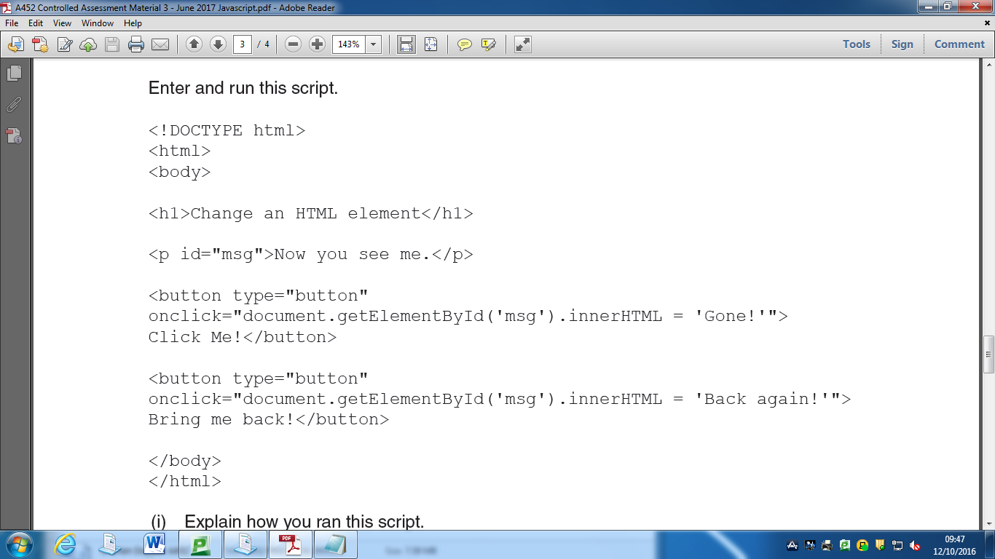Explain how you ran this script.

I first needed to find out where I would write the HTML I didn’t know how to so I looked up on Google and checked some websites and found the answer on w3schools.com. I found out that I had to use Notepad to try out the code. I didn’t know this before as I usually just did it using code academy’s editor.

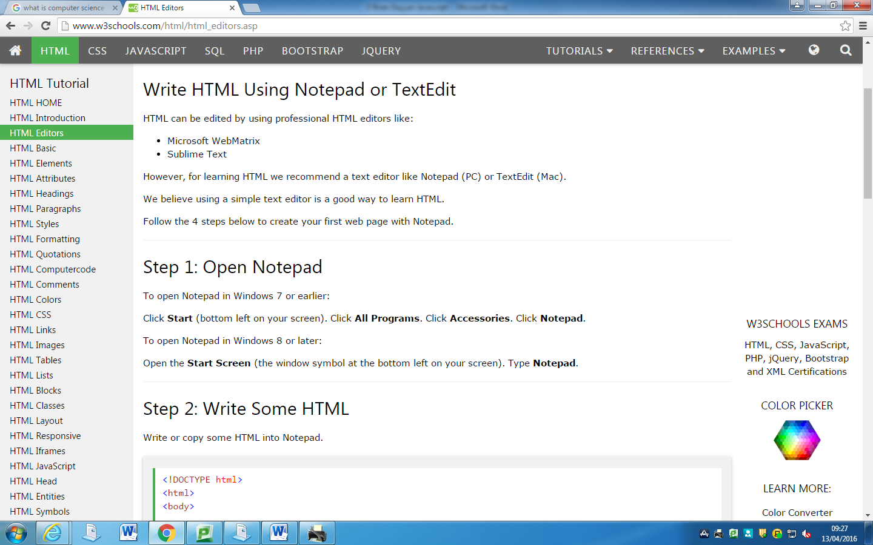

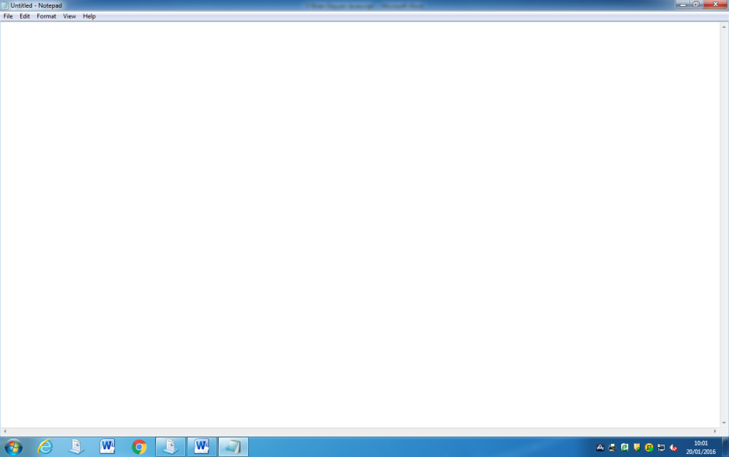I then opened up Notepad; I could now paste the given code in here. This was pretty simple and general knowledge for me. I then proceeded to enter all the code into the document as well as filling in a few extra lines as I wanted to experiment working with HTML. This would be a gif image and some of the text being changed.

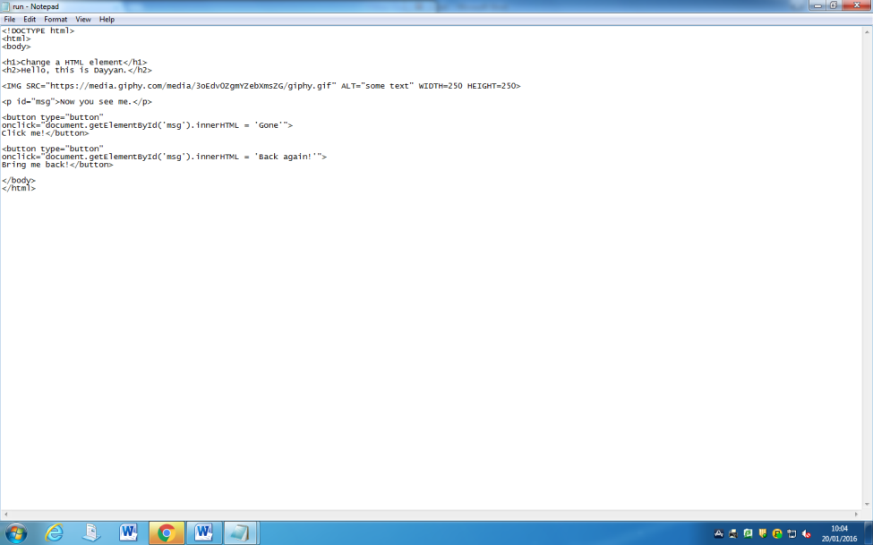

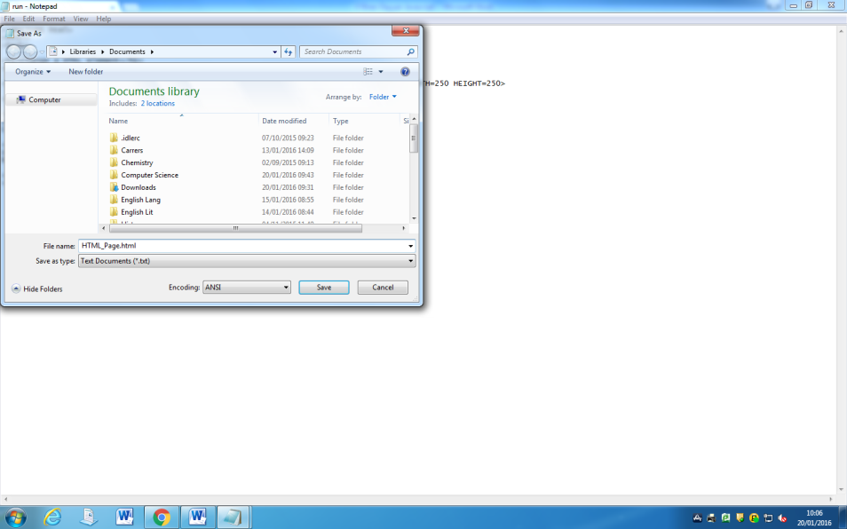I then saved it as an .html; this gives me the ability to open the document in a browser. I found out how to do this earlier through the same w3schools page that told me I should open it through notepad.

Finally, I opened the document from my documents, by double clicking the saved document to open it in a browser. The following was the result:

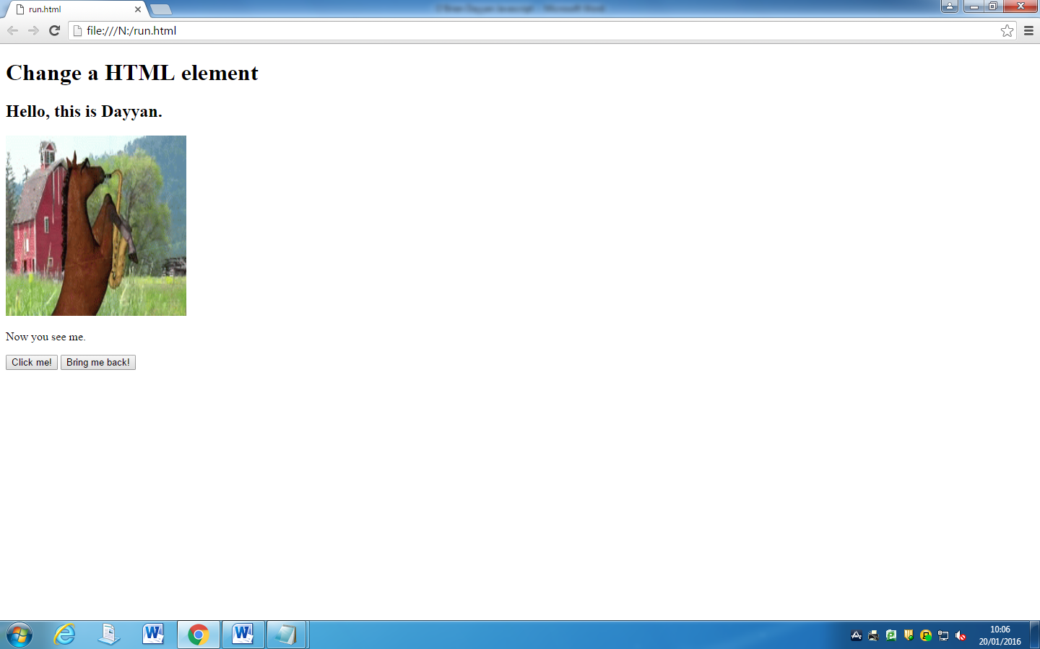

Conclusion:

This taught me how to make a HTML file on my own side, not an online IDE, this was because when coding prior to this coursework as a hobby I used online editors such as code academy for JavaScript & HTML and IDE’s such as eclipse for Java. It also helped me experiment with images in JavaScript which effectively helped me have a better and refreshed understanding of the structure of HTML since it was a while since I used HTML. This will help me when tackling future questions in terms of opening, saving and running the code that I have created.

# Question 1 (ii):

Explain what each line of the script does.

When looking through the code given, I already knew most of what was written due to prior experience working with HTML and JavaScript, I also knew other parts because some English some of the code was understandable just by reading it, such as <button> which is clearly a button. This enabled me to easily write all meanings without much trouble, the only one that I didn’t know before researching was <!DOCTYPE html>.

1. <!DOCTYPE html> It is an instruction to the web browser about what version of the mark-up language the page is written in. It tells the browser how to render the page.
2. <html> This defines the root of a HTML document and describes a HTML document.
3. <body> This defines the document's body and all within describes visible content.
4. <h1>Change a HTML element</h1> This creates a heading, in this case being “Change a HTML element”.
5. <p id="msg">Now you see me.</p>

This creates a paragraph, in this example the message shown will be “Now you see me.” As it is in between the <p> and </p>. id=”msg” creates a special id for the element, it will be used on line 9 and 7 at the getElementById

1. <button type="button"

This creates a button, the type=button. Tells us it is a clickable button.

1. onclick="document.getElementById('msg').innerHTML = 'Gone'"> When the button is clicked, “Gone!” will pop up from the ID msg, which is “Now you see me”.
2. Click me!</button>

This shows the text that will be on the button; in this case it will be “Click Me!”

1. <button type="button" This creates a button, the type=button. Tells us it is a clickable button.
2. onclick="document.getElementById('msg').innerHTML = 'Back again!'">

When the button is clicked, “Back again!” will pop up from the ID msg, which is “Now you see me”.

1. Bring me back!</button>

This shows the text that will be on the button; in this case it will be “Click Me!”

1. </body> This ends documents body.
2. </html> Ends root of HTML document

Conclusion:

This helped me gain a better understanding of the meaning of the individual lines in the file. I had a good understanding of most of this such as paragraphs, body and html. And while I did have a basic understanding on how buttons work, it did help me better understand exactly how it works (e.g getElementById & onclick) within HTML, which would be useful in later questions; though I still didn’t fully understand them and how they worked. I feel learning these basic lines will be useful in the case that I use some of them in future questions.

# Question 2 (i):

As is the case with most programming languages, in JavaScript you can use arrays in order to store multiple values under the same identifier.

For example, an array of products can be set up as below for use on an ecommerce web site:

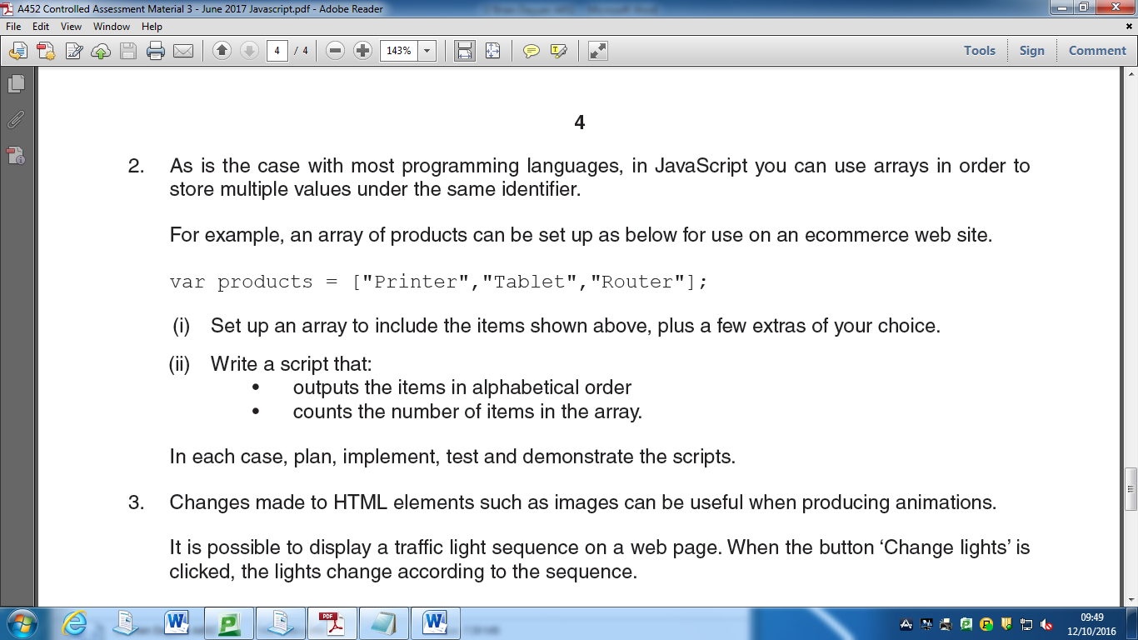

Set up an array to include the items shown above, plus a few extras of your choice.



Above is already an array so I just had to add a few more products, these will all have commas between them except on the last element and each product will have quotation marks to show each array. Once again, because of prior experience I already knew how to use arrays, and also saw the pattern between each product. All I had to do was add products in speech marks, with a comma after each product except the last one, this I found simple enough and easy so I got it done without any problems whatsoever.

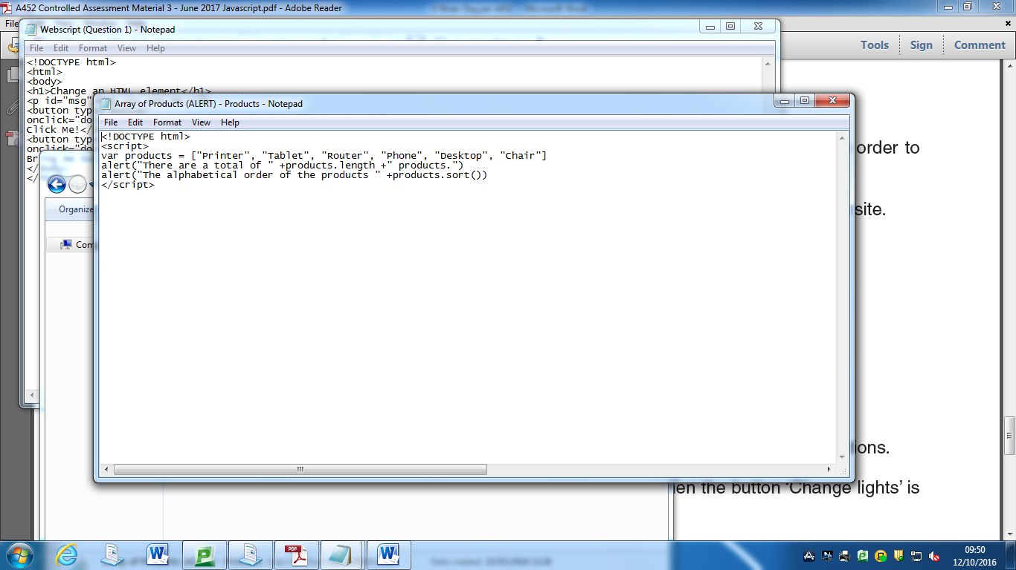

Conclusion:

I didn’t really learn much from this question, while it did give me a light refresh on how arrays work like I said, I already had a good clutch on how arrays work. This will, however help me later on in the case that I use arrays within my code.

# Question 2(ii):

Write a script that:

• outputs the items in alphabetical order

• counts the number of items in the array.

In each case, plan, implement, test and demonstrate the scripts

Firstly I had to plan it, what I wanted to do was to create a variable of the array from my answer on Question 2(i) and put this in a script

I then wanted to try printing it, upon research I found I could use products.length and products.sort(), however when trying this and pasting them both in, only one of them would pop up, which meant I would have to get around this a different way.

I looked up on Google on arrays and found out that you could use alert() instead. (http://www.w3schools.com/jsref/met_win_alert.asp)

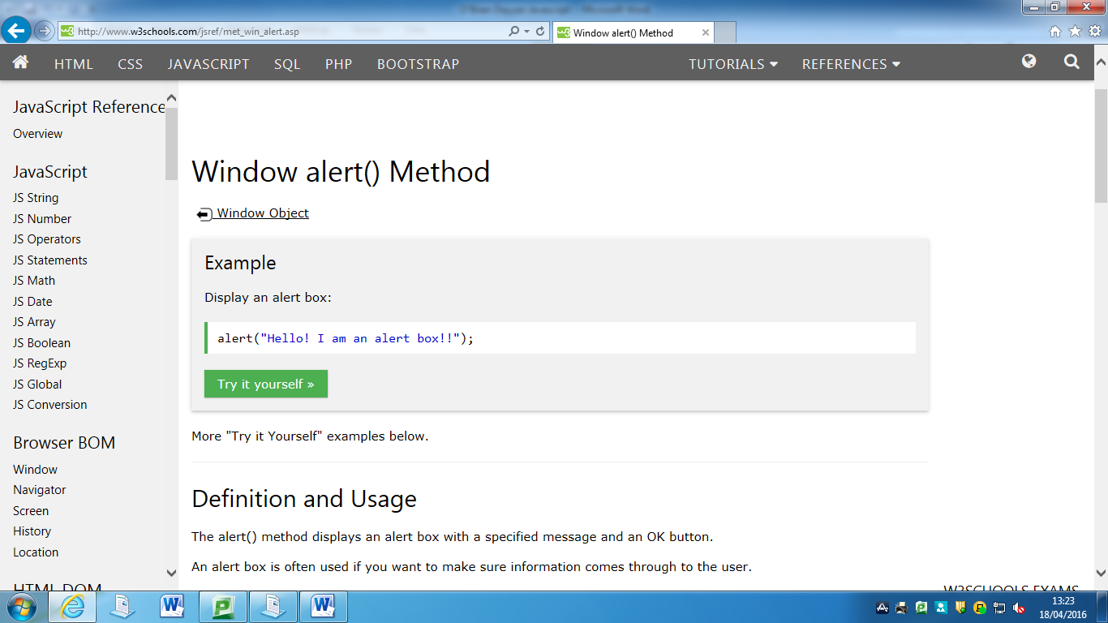

([http://www.w3schools.com/jsref/prop_nodelist_length.asp)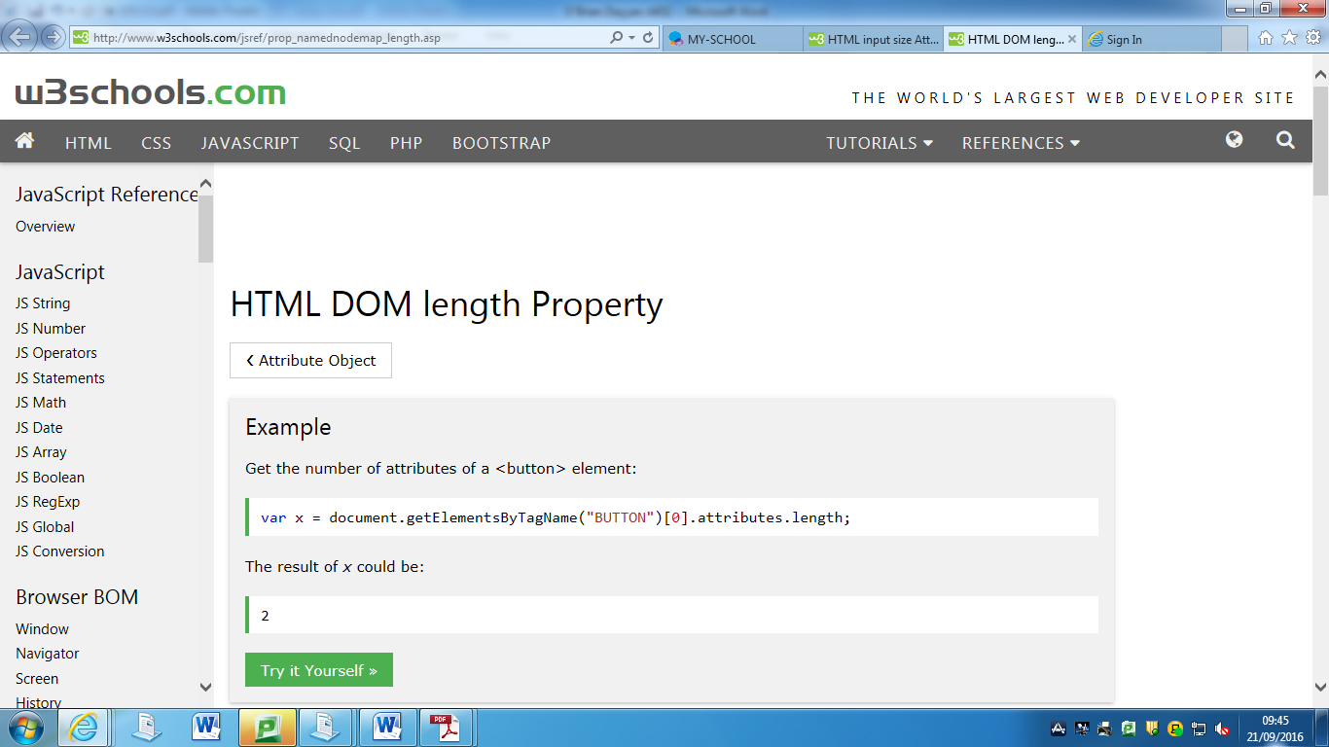](http://www.w3schools.com/jsref/prop_nodelist_length.asp#))(http://www.w3schools.com/jsref/jsref_sort.asp)

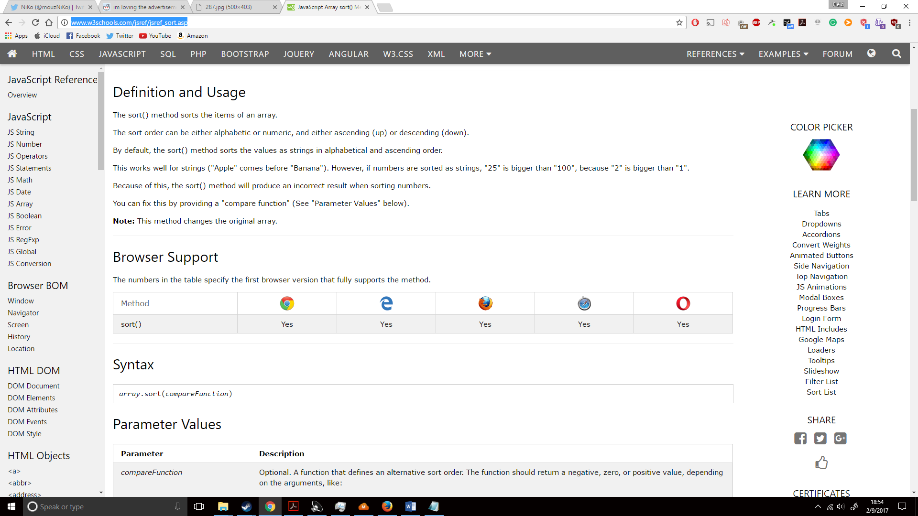

I then needed to create variable call products, and I could just add .length and .sort() to the end of them, this enabled an easy fix to the issue. The rest of it was fairly easy to use and I had no errors when doing it.



This is the entirety of everything done together. The <script> is where you insert your JavaScript that you have written so it can be functional on a webpage, however I didn’t have to here as this was a script.js document. The following was done in codeacademy due to me liking the colours used which makes the code look neater.

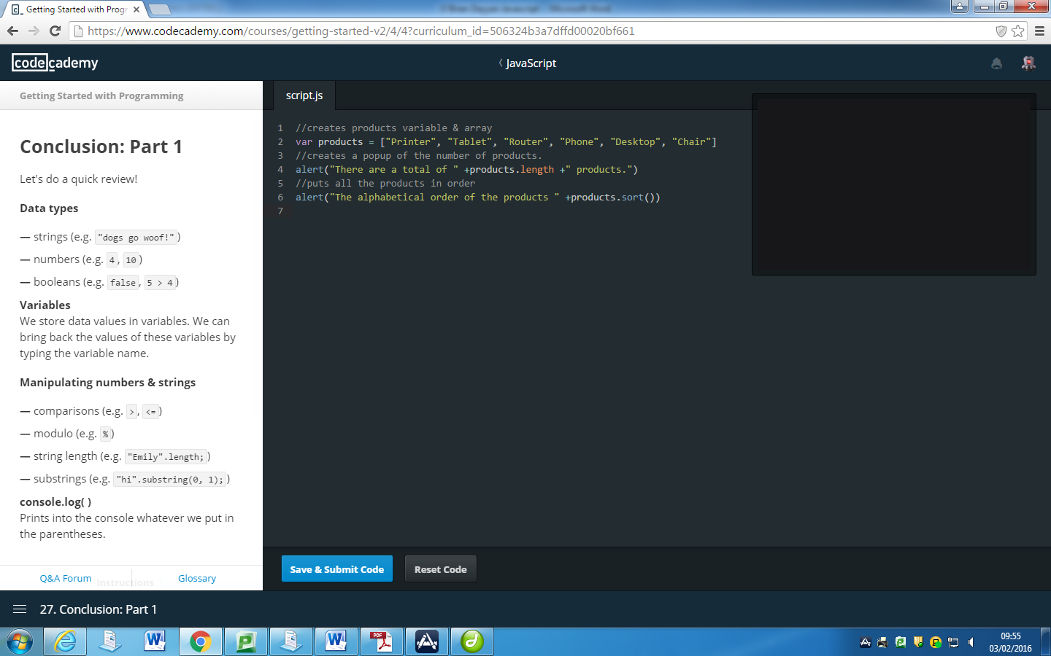

Above is all the written code in code academy, now I could simple press the Save & Submit Code button to run it and see if it worked correctly.

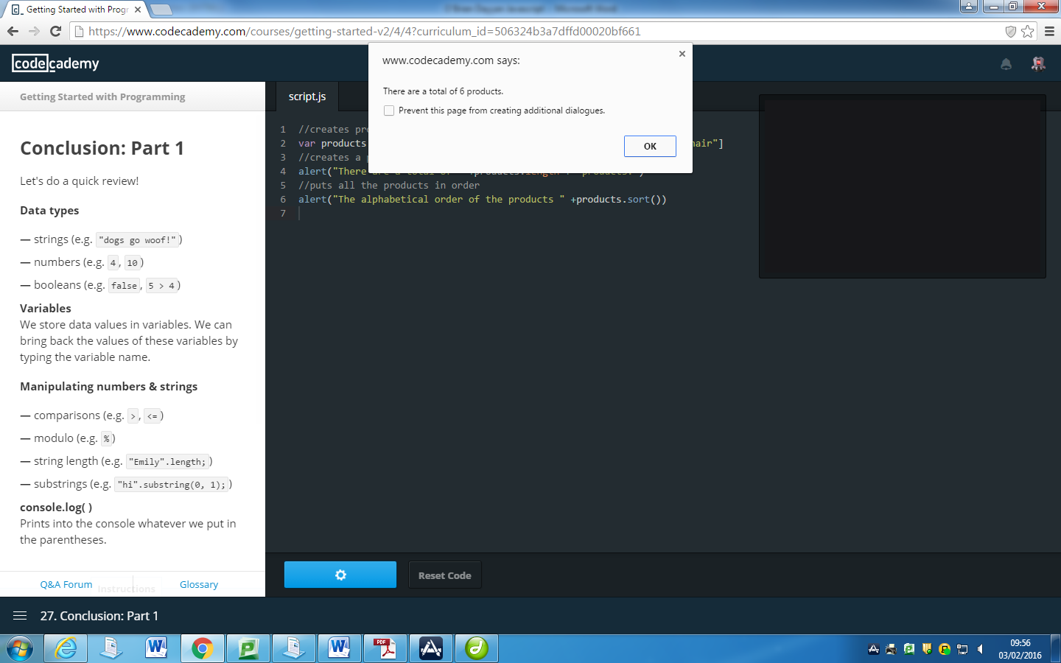

The number of products worked correctly, now onto the products in alphabetical order.

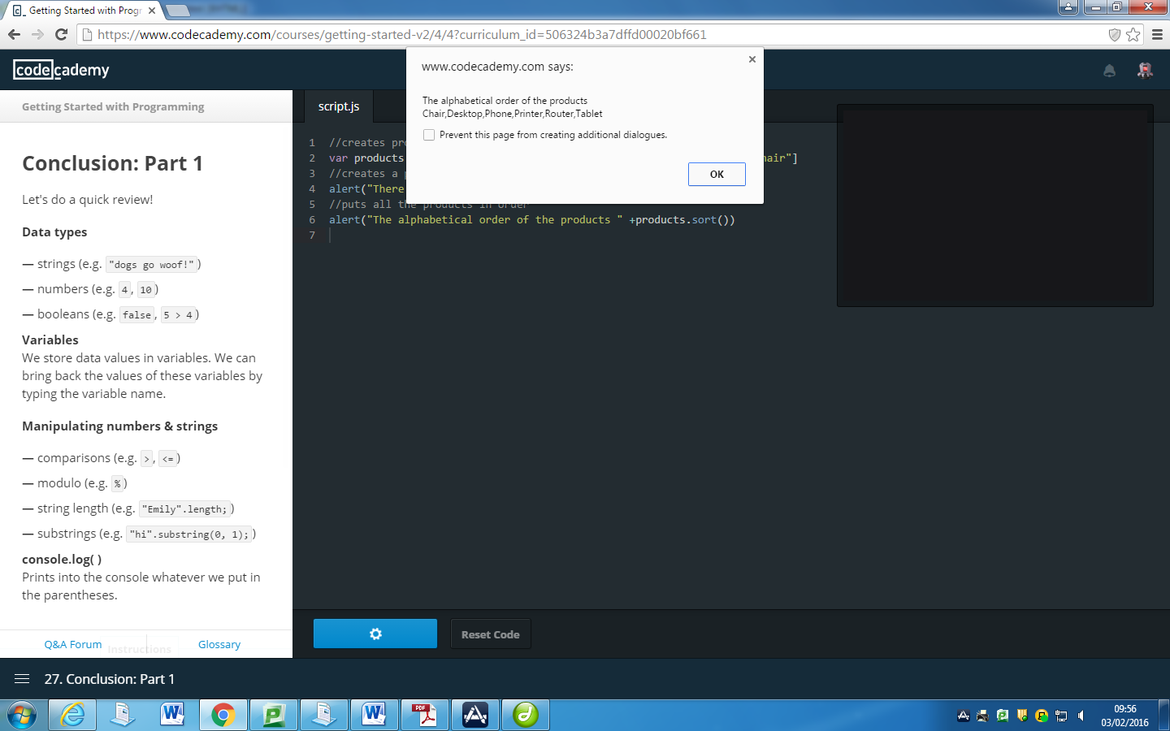

The code was successful!

**PSEUDO CODE**

START

IMPORT array of products = “Printer, Tablet, Router, Phone, Desktop, Chair”

ALERT total number of products

ALERT products in alphabetical order

END

**FLOWCHART**

START 

ALERT PRODUCTS ALPHABETICALLY

ALERT NUM. OF PRODUCTS

INPUT PRODUCTS

STOP 

var products = ["Printer", "Tablet", "Router", "Phone", "Desktop", "Chair"]; Above is the array of all the products I will be using to sort and find the number of items. The variable is named ‘products’.

alert("There are a total of " +products.length +" products.") Above by default automatically, orders the chosen variable into an alphabetical order. You can see the ‘products’ before the dot. This is where you write the variable you would like to choose. The alert will create a popup saying “There are a total of <number of products> products”.

alert("The alphabetical order of the products " +products.sort()) Similar to ‘products.length’, before the dot your write the variable you would like to choose, once again ‘products’. The alert will create a popup saying, “The alphabetical order of the products is <alphabetical order of the products>”.

TESTING

|  |  |  |
| --- | --- | --- |
| PRODUCTS? | EXPECTED RESULT | CHANGE NEEDED? |
| Printer, Tablet, Router, Phone, Desktop, Chair | Yes – 6 products and order shown was “Chair, Desktop, Phone, Printer, Router, Tablet” | N/A |
| Dogs, Cats, Birds, Hamsters | Yes – 4 products and order shown was “Birds, Cats, Dogs, Hamsters” | N/A |
| BMW, Opel, Mercedes Benz, Nissan, Fiat | Yes – 5 products shown and order was “BMW, Fiat, Mercedes Benz, Nissan, Opel” | N/A |

Conclusion: This helped me gain a better understanding on how to apply arrays to my work. I found how I could find the numbers of items in an array and apply it in alphabetical order. I learnt how it could be used in future pieces of code where I could, for example go through all my arrays in a specified order which I have stated. This may be useful in future questions when trying to run an array in a specified order as well as trying to get metadata about an array.

# Question 3(i):

Changes made to HTML elements such as images can be useful when producing animations.

It is possible to display a traffic light sequence on a web page. When the button ‘Change lights’ is clicked, the lights change according to the sequence.

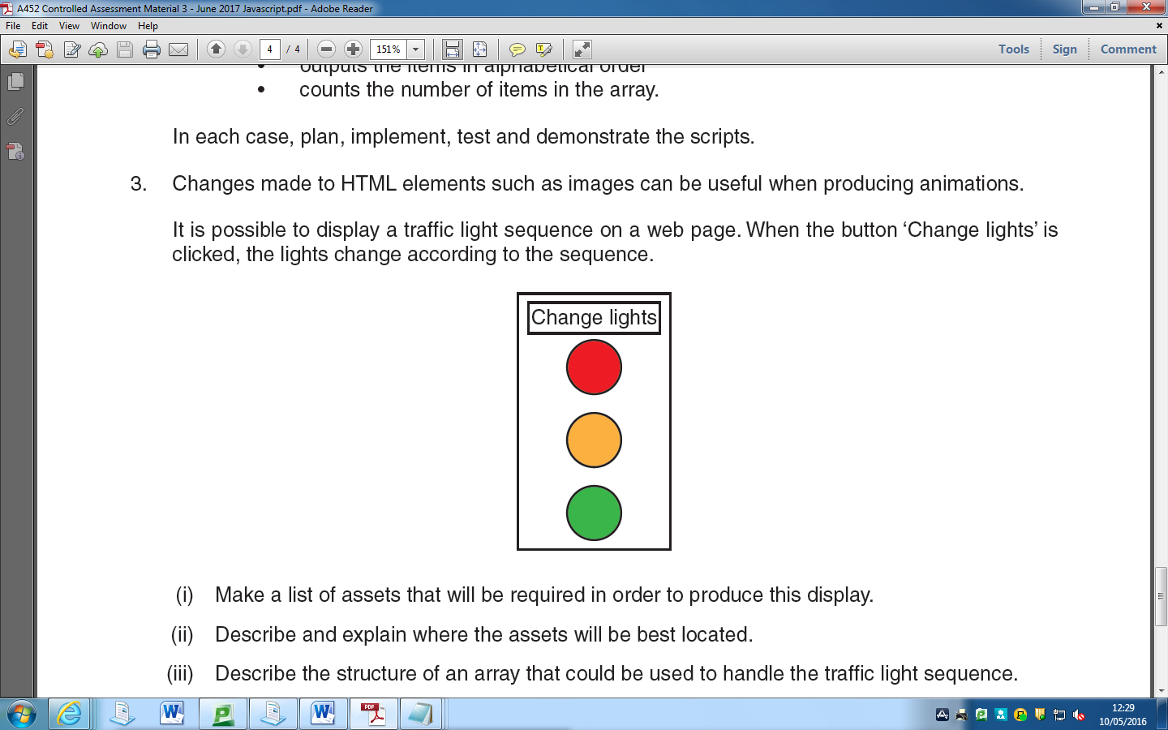

Make a list of assets that will be required in order to produce this display.

I have a total of four assets, each being a different state of the traffic light. It will go from the left image to the right image and then back to the left again in an endless loop. This could be done in many ways such as if statements, I also feel all four traffic lights are aesthetically pleasing and even though bad looking traffic lights wouldn’t break the functionality it’s one of those things that I personally find important. I got these online and then edited it.

 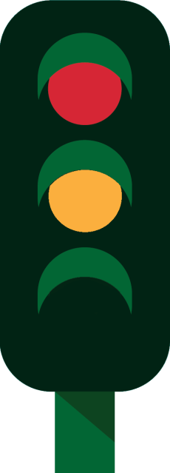

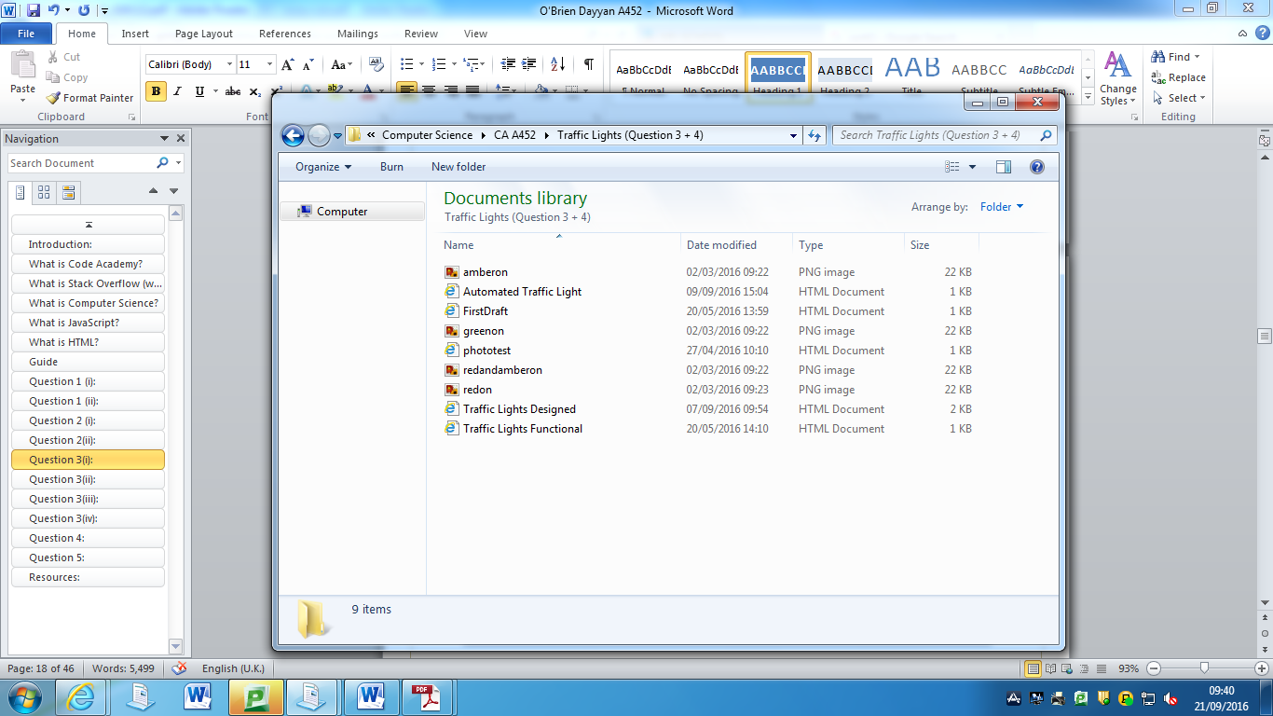

I then decided to store my photos in my files, however I did not know how to show images from files in JavaScript.

Image file names:

* redon.png
* redandamberon.png
* amberon.png
* greenon.png

Conclusion:

This showed me how to put photos on my client side as I usually had it uploaded to a website online, I knew I could do this as I have seen code before where people have used images like this. This is useful as it doesn’t require an internet connection for it work. This also gave a quicker connection with my code and the images making them load up quickly rather than relying on online server speeds. I used images instead of CSS as I found images personally much easier to use and apply in my code. These images will be used in later questions where I use the traffic light images, hence helping me later.

# Question 3(ii):

Describe and explain where the assets will be best located.

I already knew one method of uploading assets because of previous knowledge and Question 1(i); this would be through uploading the photos to picture uploading websites such as imgur.

However, some websites would delete the pictures over time and the code would not be programmable without internet connection as well as being harder to write down the url than for example photo.png, which I didn’t always have. It is also much faster to access (as servers can be quite slow!) from your files than the web. In addition, the fact I wouldn’t have to type out the full link of the image saves time and makes code much easier to read for others using it. I will save the files in the same folder makes all my sources cleaner and easier to access rather than hidden somewhere. And finally while if I did choose to store it online and wouldn’t have to download it with the program; I feel that that negatives are much worse for hosting online. I knew you could also add images which were in the same file but I didn’t know exactly how to. So, I searched on Google and found this:

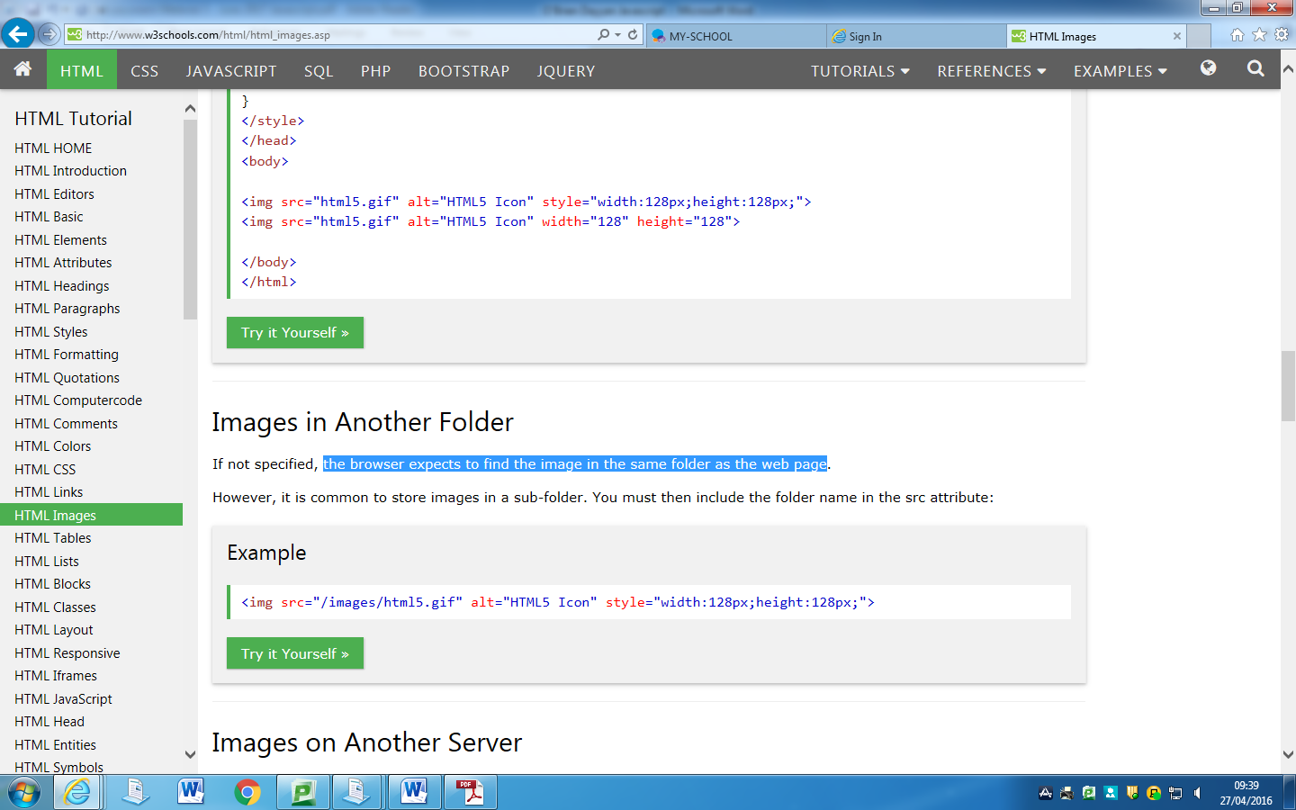

According to the website I got it from (w3schools.com), I found out that “the browser expects to find the image in the same folder as the webpage”. Due to this I added all four of my images in the same document where my code would be.

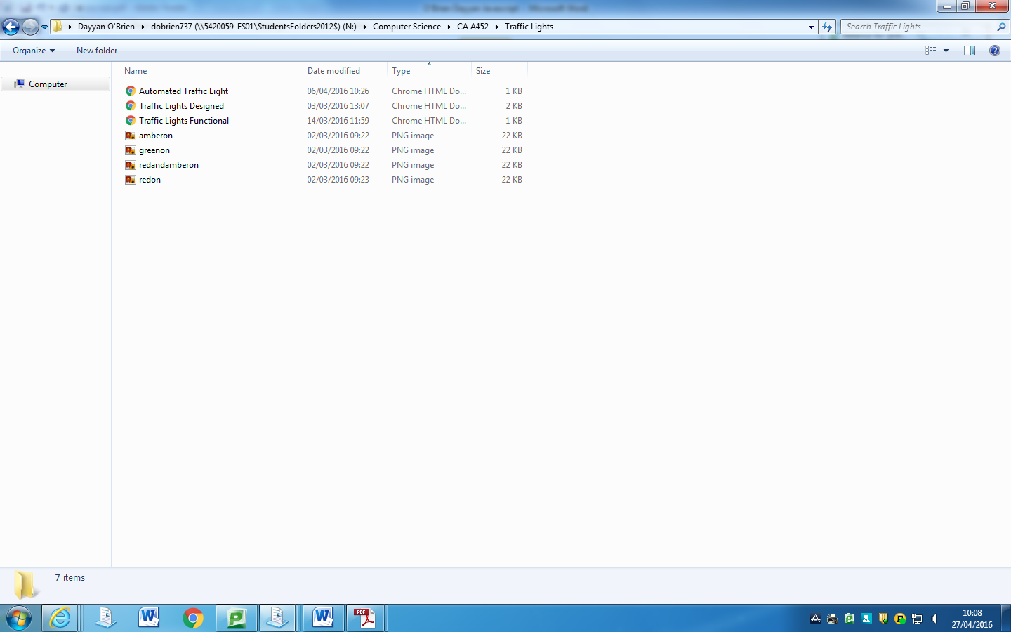

I didn’t know how to show images from my files so I researched and found that I could run it by naming the file name if the html file is in the same folder as the image. (http://www.w3schools.com/html/html_images.asp)

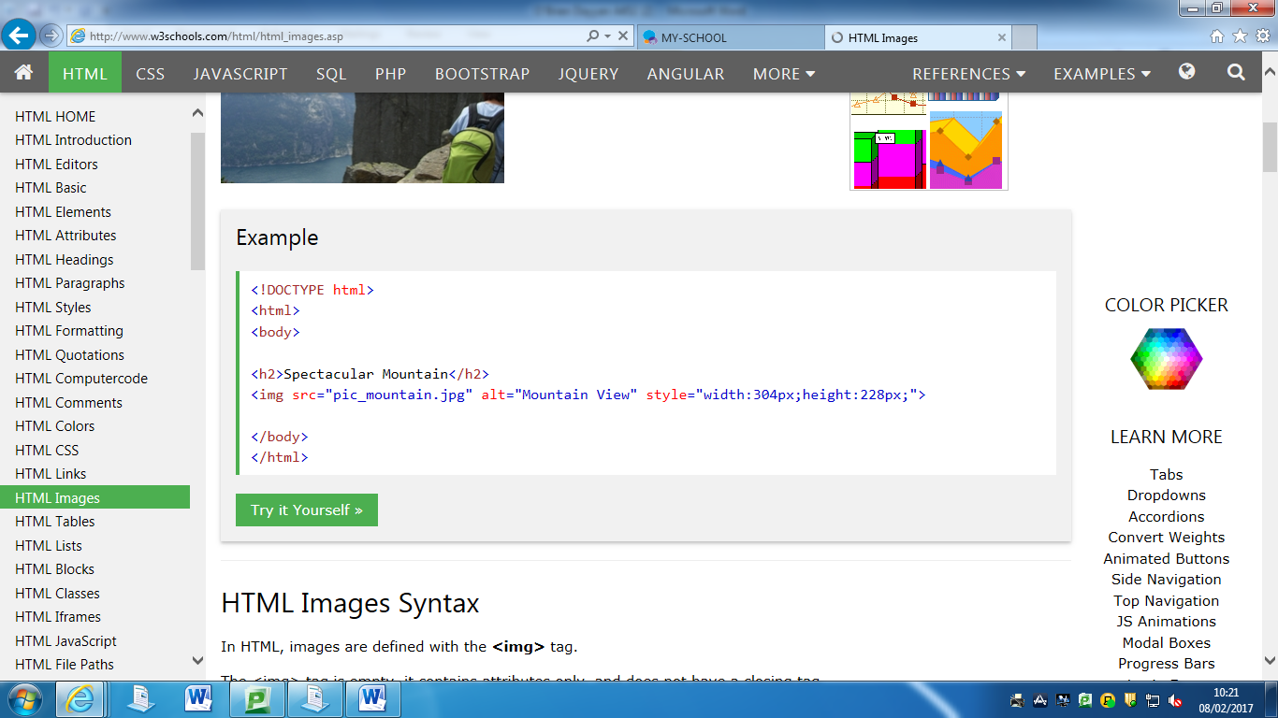

I then tested it out with this HTML to check if it would work correctly:

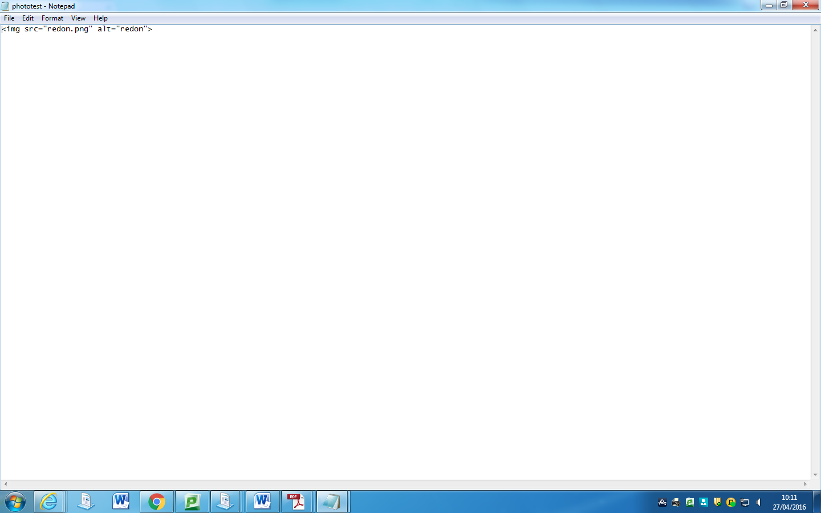I then ran it, and the result was successful, I now knew how to put images in a HTML document without uploading them online to a website where it would be harder to write and use.

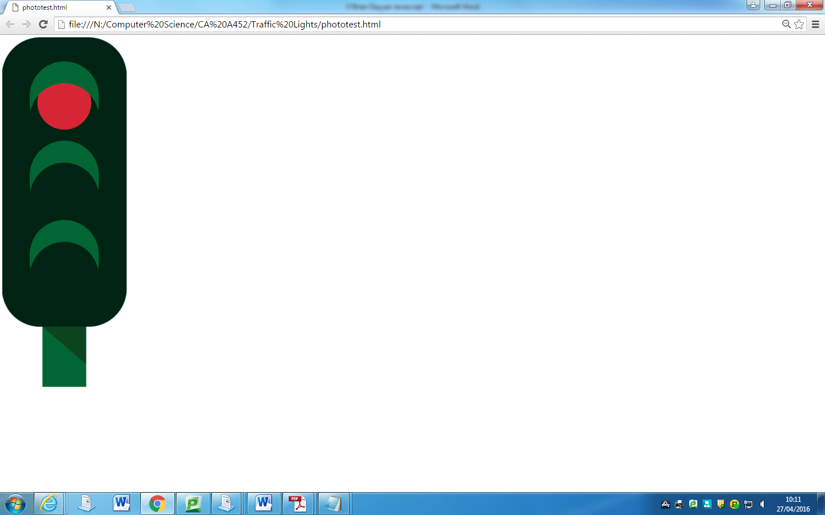

Conclusion: This makes working with images much easier and helped me considerably with my code. It also showed me how to code images from files into my code. This gave me a much more in-depth understanding of HTML code and how it works and I will apply this in the later parts of question 3.

# Question 3(iii):

Describe the structure of an array that could be used to handle the traffic light sequence.

The structure of an array that could be used to handle the traffic light sequence will be set in the order I would like the traffic lights to appear, there is four possibilities. I am using:

red -> red and amber -> green -> amber

I could also use:

red and amber -> green -> amber -> red,

green ->amber -> red -> red and amber,

amber -> red -> amber -> green.

These all would work in real life, as that’s how a normal traffic light’s order would go. However, from the above, it is all a matter of personal preference.

Conclusion: This helped me plan how my traffic lights would work, the order it would go in and should help me with the final part of question three. This also showed me the order I would use the array for my traffic lights, as if I used alphabetical like I did for a previous question it would not work in the correct order unless I named the images 1.png, 2.png etc. This helped me as I will have used this order in later parts of this question.

# Question 3(iv):

Write a script that uses the array described in part (iii) to produce an animation of a set of traffic lights such that the lights change in the standard sequence each time the button is clicked.

I first needed to create the ‘spine’ of the code. This would hold to code together and make it much easier to put things in certain places. The lang=en specifies a language code, in this case being English. This was fairly simple, and I had no problems when typing it out.

<!DOCTYPE html>  
<html lang="en">  
<head>  
</head>  
<body>  
</body>  
</html>

I then added a button to the code; I would add more details to the button later to add styles and an onClick event. It would be a button, with nothing inside it as I didn’t know how to program on click yet, but for now this was what I had on button: <button> and a </button>. This will be located within the body as it is visible content.

<button></button>

I then added some information to the button, which would be the text that you see on it. I had to add the text between each of the buttons that I wanted in it.

<button>Change Lights</button>

I then proceeded to add type = button inside the first button. This would make the attribute value a clickable and functional button.

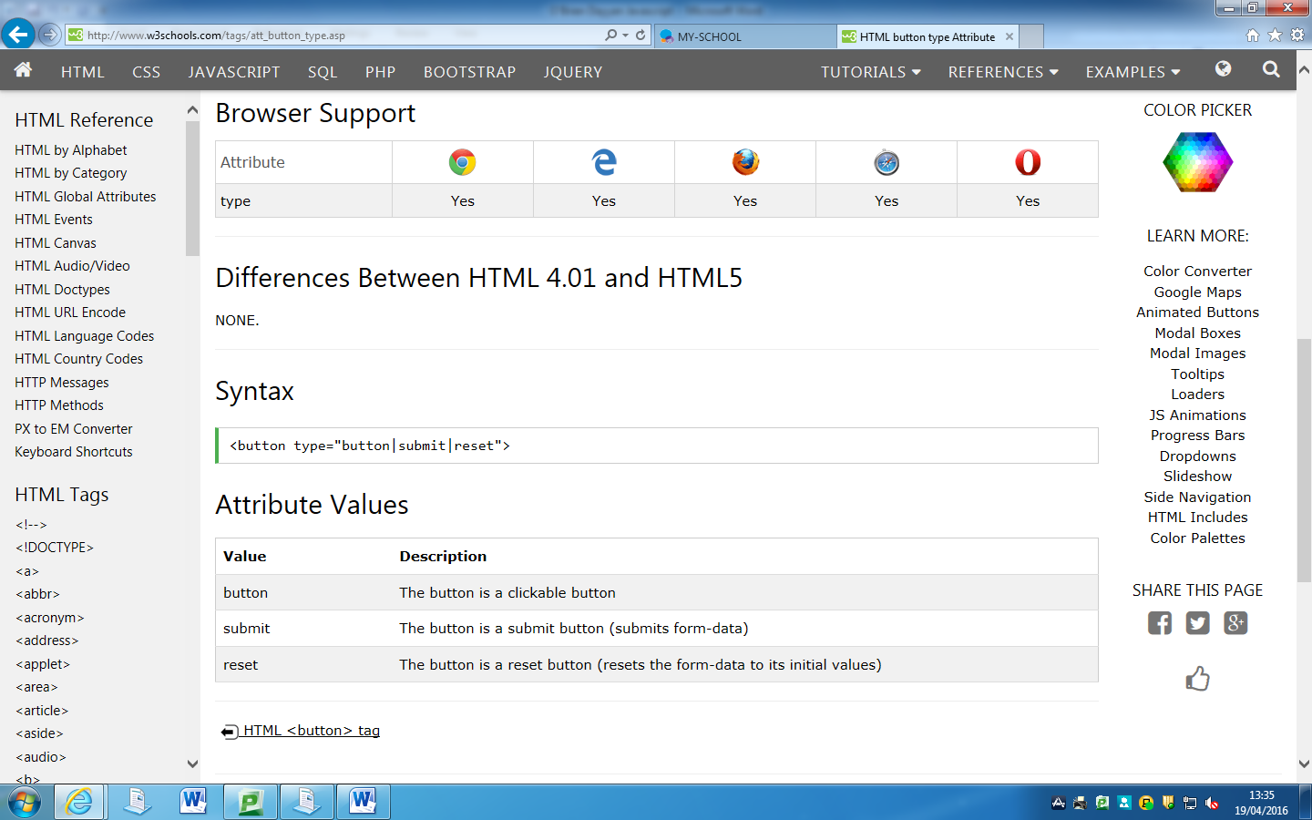

<button type = "button">Change Lights<button>

I then had to think of a way to make the traffic lights worked. One of the methods that I thought of was the image changing each time the button was pressed, I had no idea where to start but I made a <script> with the function name I wanted (changeImage)  
<script>  
function changeImage()  
</script>

I then added an onClick event so when I press the button it would run the action which I would have stated. I found the following on onClick events. This would be used to change the image of my code by running the changeImage function said previously (http://www.new2html.com/tutorial/using-javascript-change-image-src-attribute/).

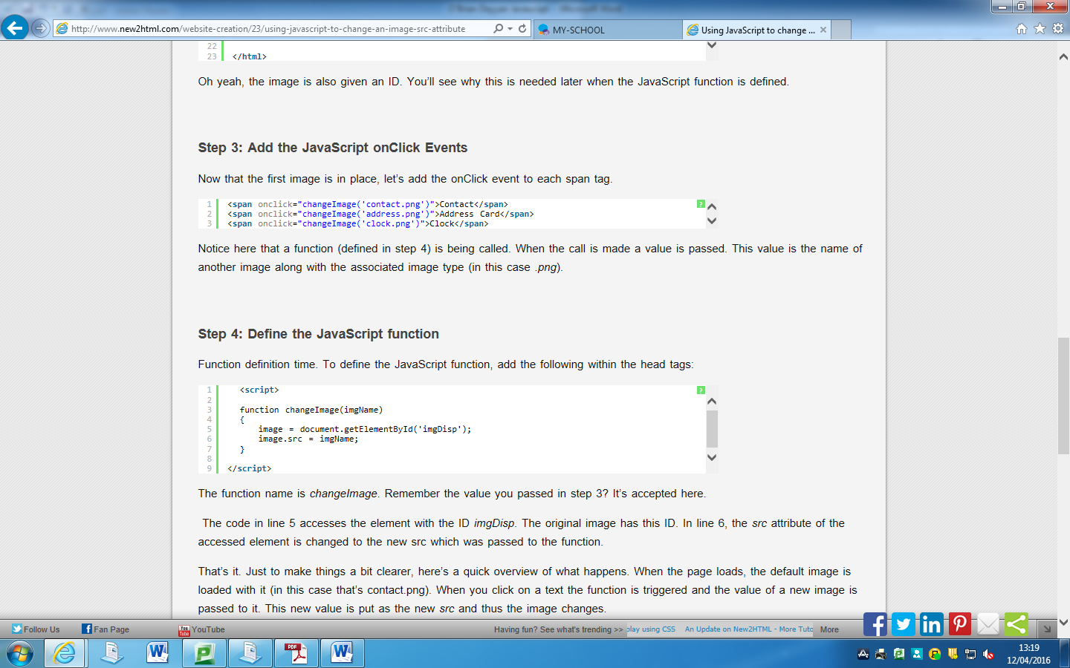

So, using the information on button clicks I added the following to my code:

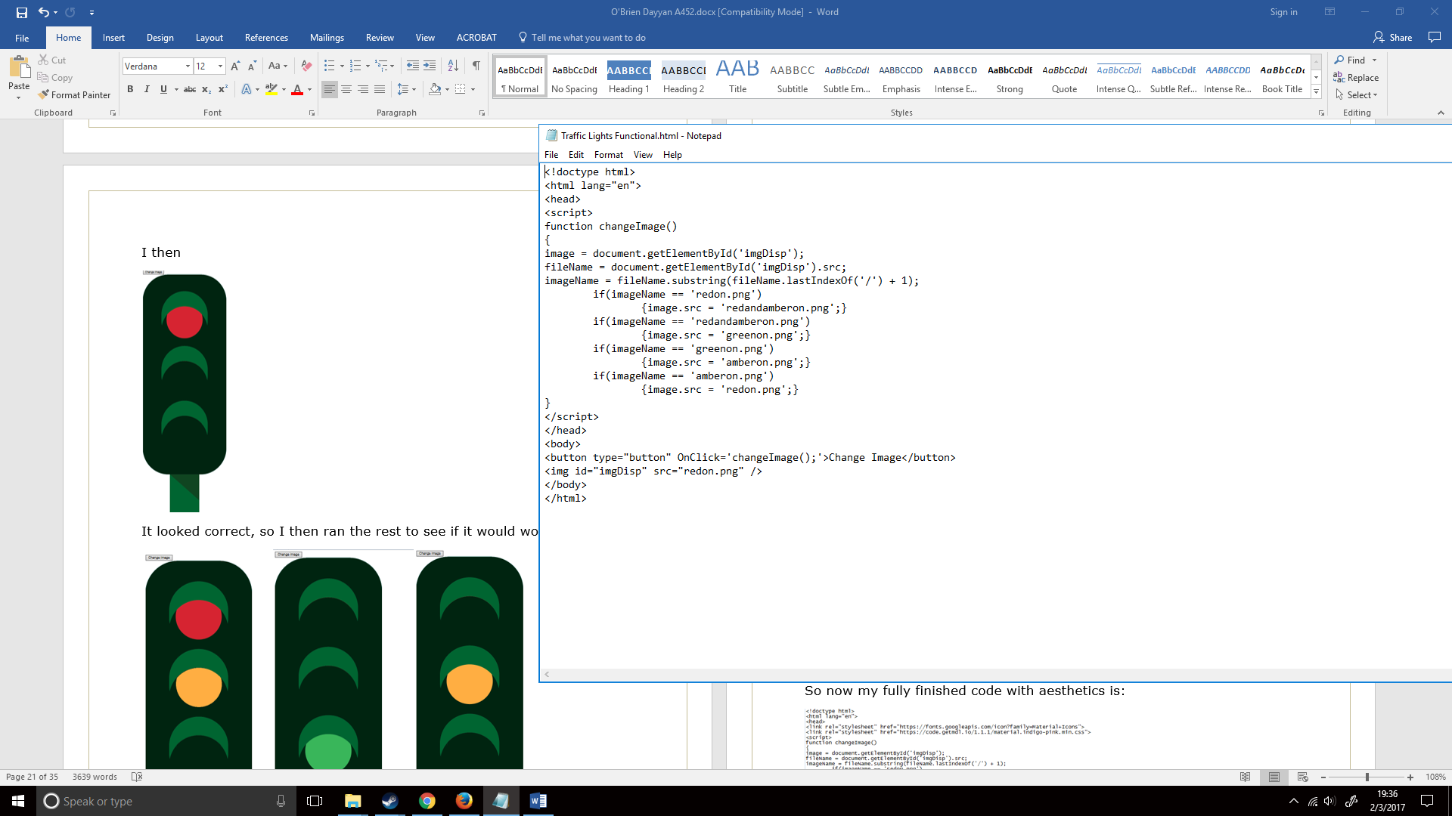

Nothing happened when I clicked the button, but this was because I didn’t add anything to the changeImage function thus far.

I then created an array for my code, this would be done like I did in the previous array questions: 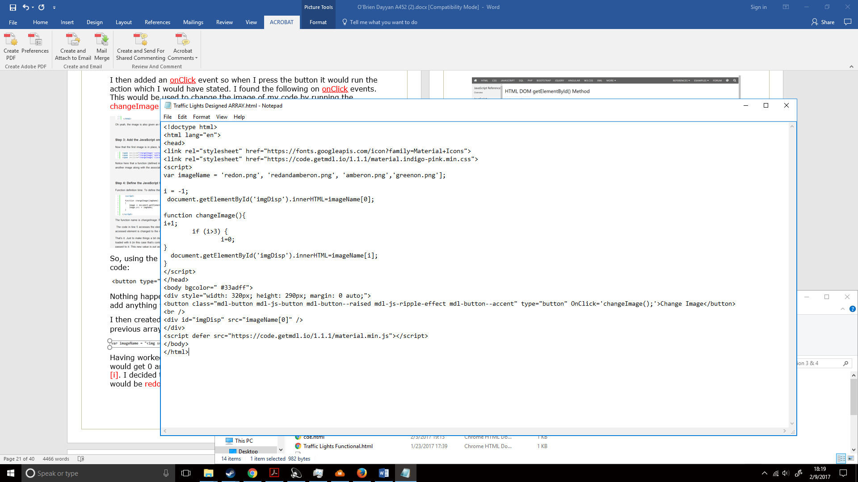

Having worked with code before I remembered how I ran a loop where it would get 0 and keep adding one forever and ever where the number was [i]. I decided to recreate this with my traffic lights so imageName[0] would be redon.png, imageName[1] would be redandamberon.png, imageName[2] would be amberon.png and imageName[3] would be greenon.png. However, this left me a problem, if it added one every time, after it reached i=3 it would go onto 4,5,6 and so on meaning it would be blank after one turn. I figured I could approach this by using an if statement. This if statement would check if i > 3, when the button was pressed again it would reset [i] to 0 so it could recreate the loop. I was ready to proceed to start working on the rest of the code.

I first had to figure a way to change the source/id of an image. One solution that I found was getElementById (<http://www.w3schools.com/jsref/met_document_getelementbyid.asp> & http://www.w3schools.com/jsref/prop_html_innerhtml.asp);

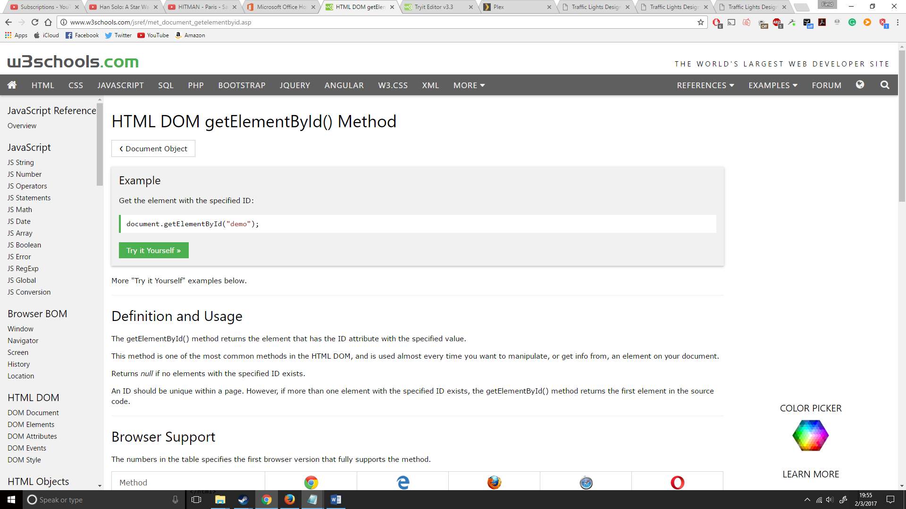

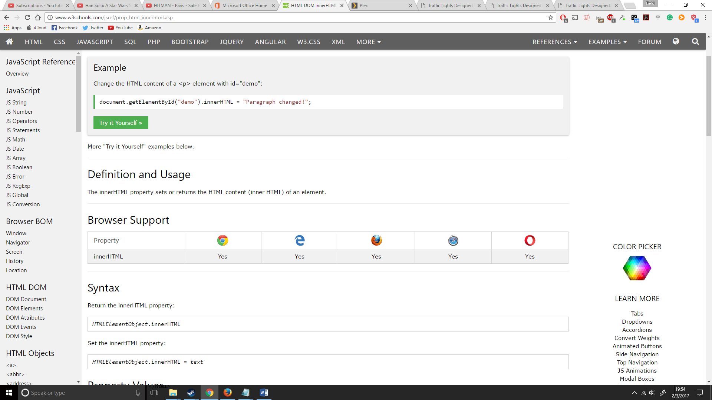

From what I found on w3schools, I could change the id of an element. So, in my sakes I could change the id of my image every time I pressed the button. So, I started by setting the id to 0, as 0 was redon.png.

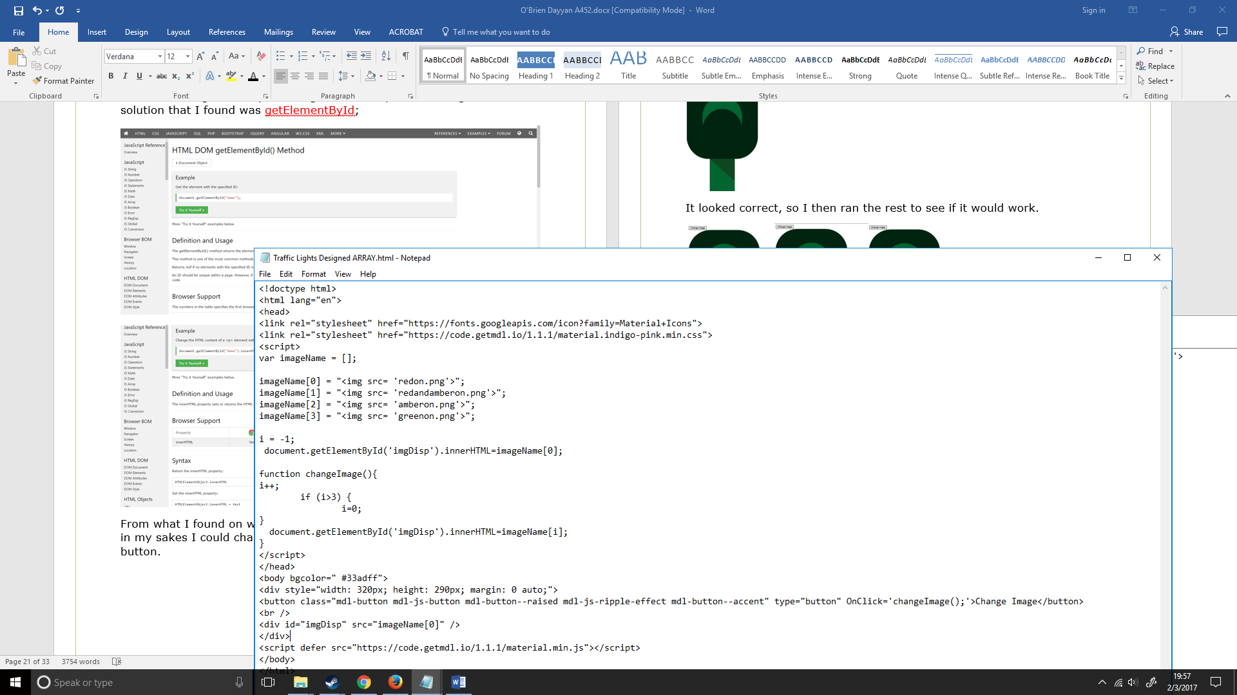

I then create an i+1 loop which would add one to i each time, making it go onto the next part of the array until it reaches the forth part (greenon.png) where it would reset it to zero when the changeImage function was ran. This would go under changeImage()

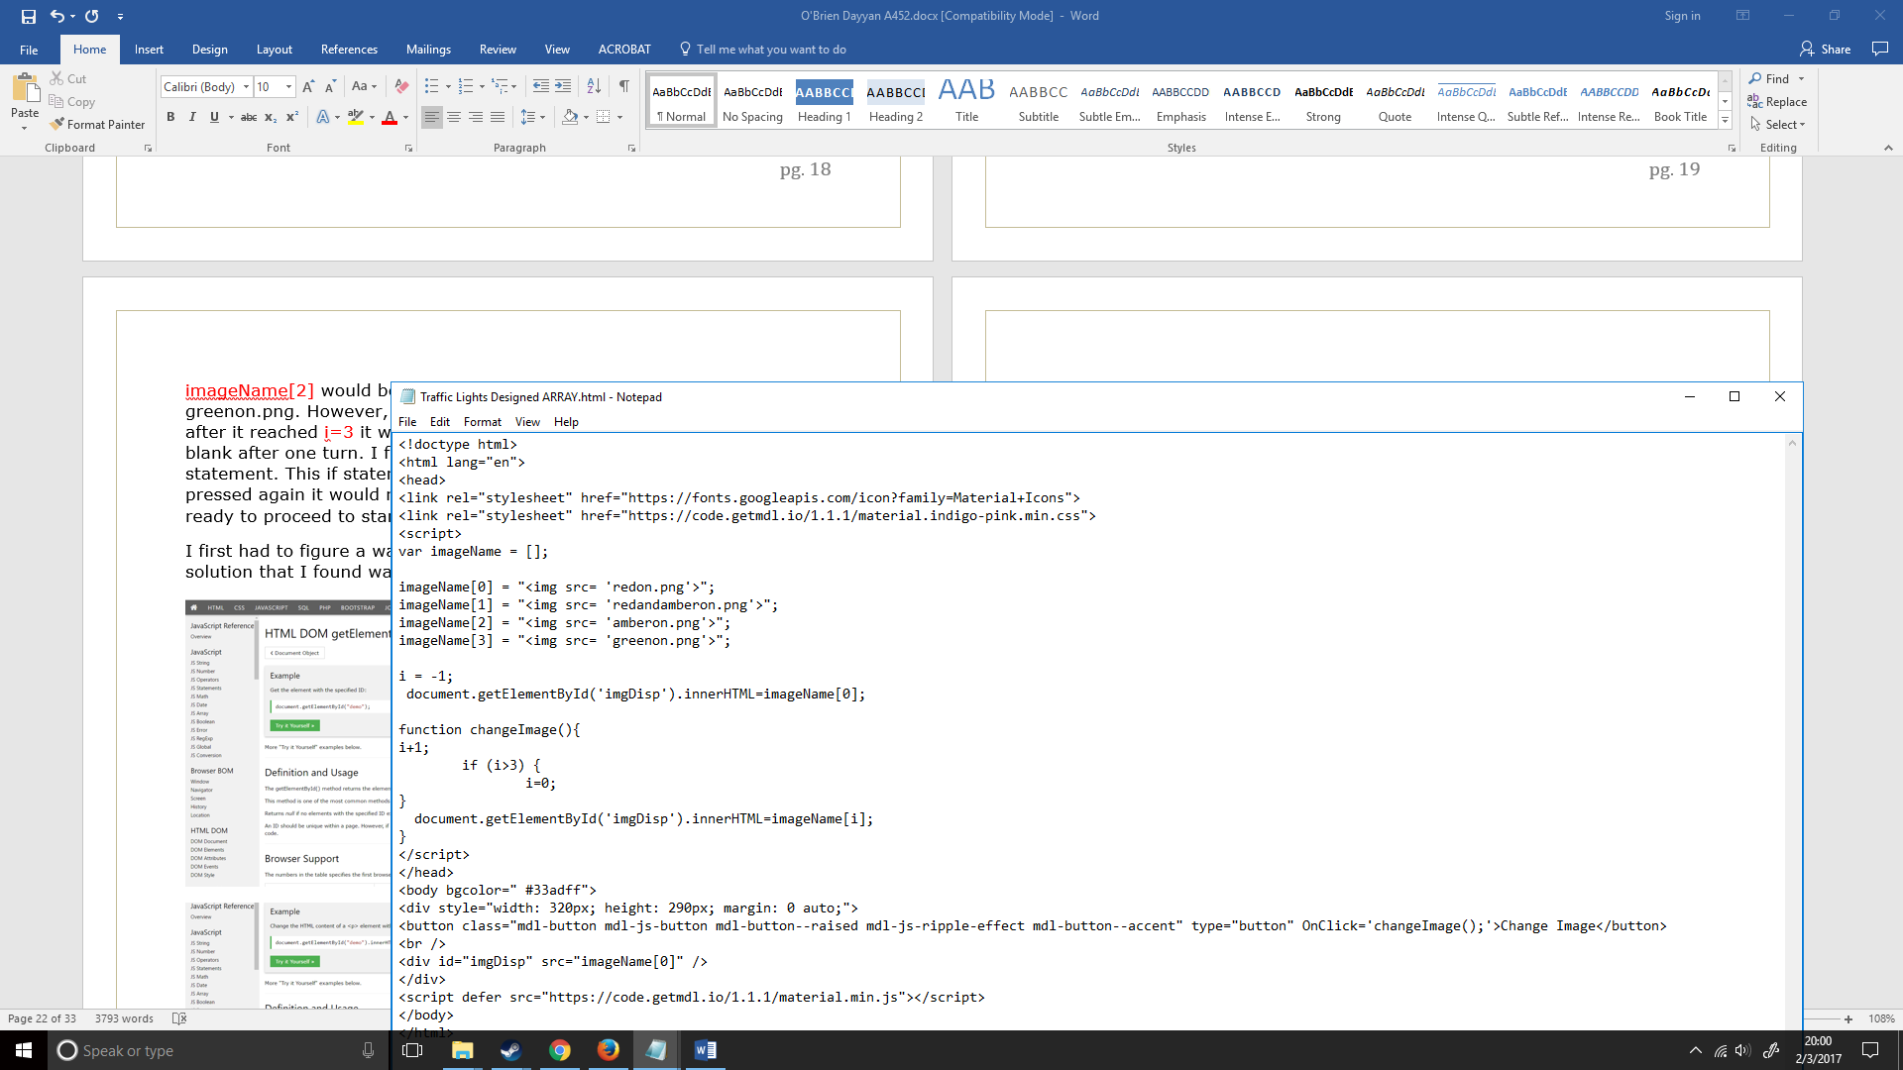

I finally created another getElementById where it would be set to [i] (the first one would be for the original image), this would allow me to change the image that is displayed each time the button is pressed, as previously I didn’t set i to go onto anything.

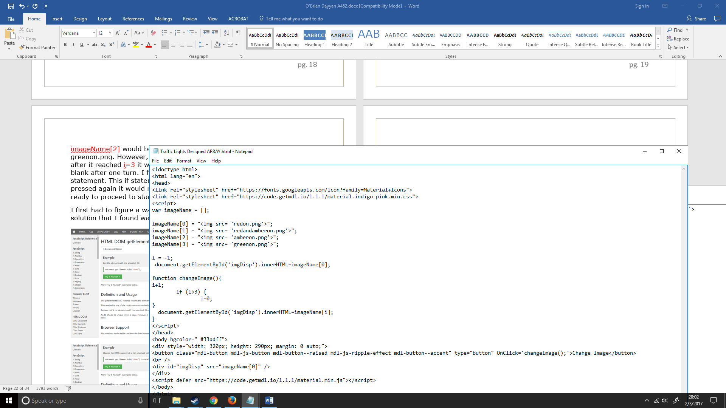

Now my full code looked like

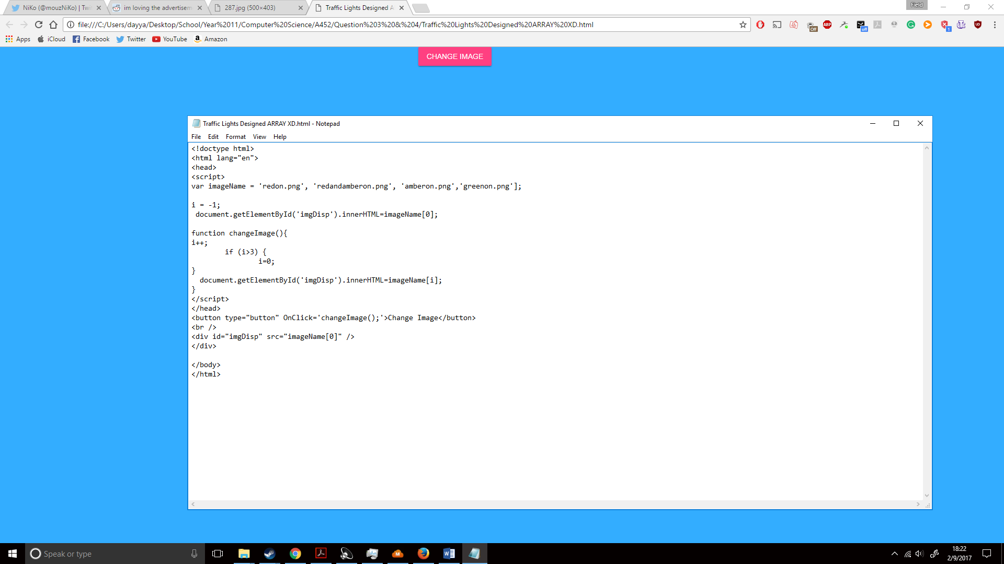

I then tried to run my code and it showed this:

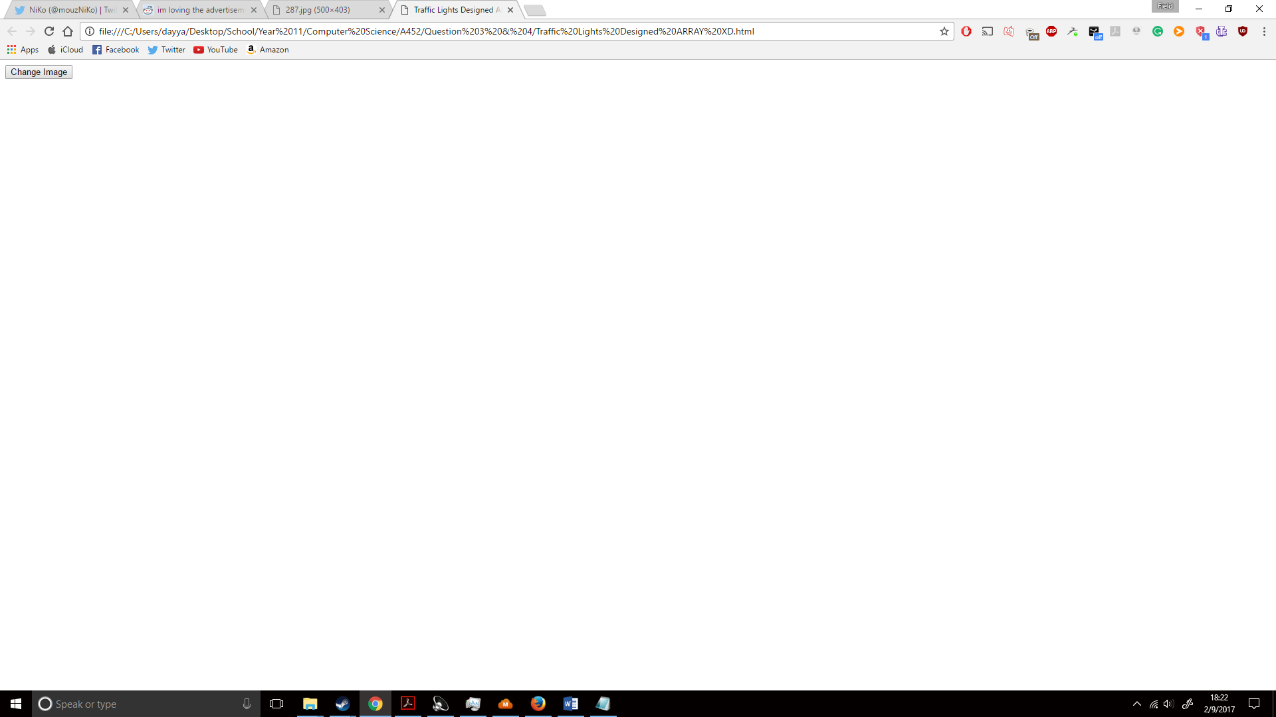

Not even an image was showing, this told me it was not a problem with the changeImage function, but a problem with either imgDisp or the imageName array. After researching around the internet on using images in arrays I noticed that they used <img src = (the image name>, so I then went to find out what <img src> was. I found the following (http://www.w3schools.com/tags/att_img_src.asp):

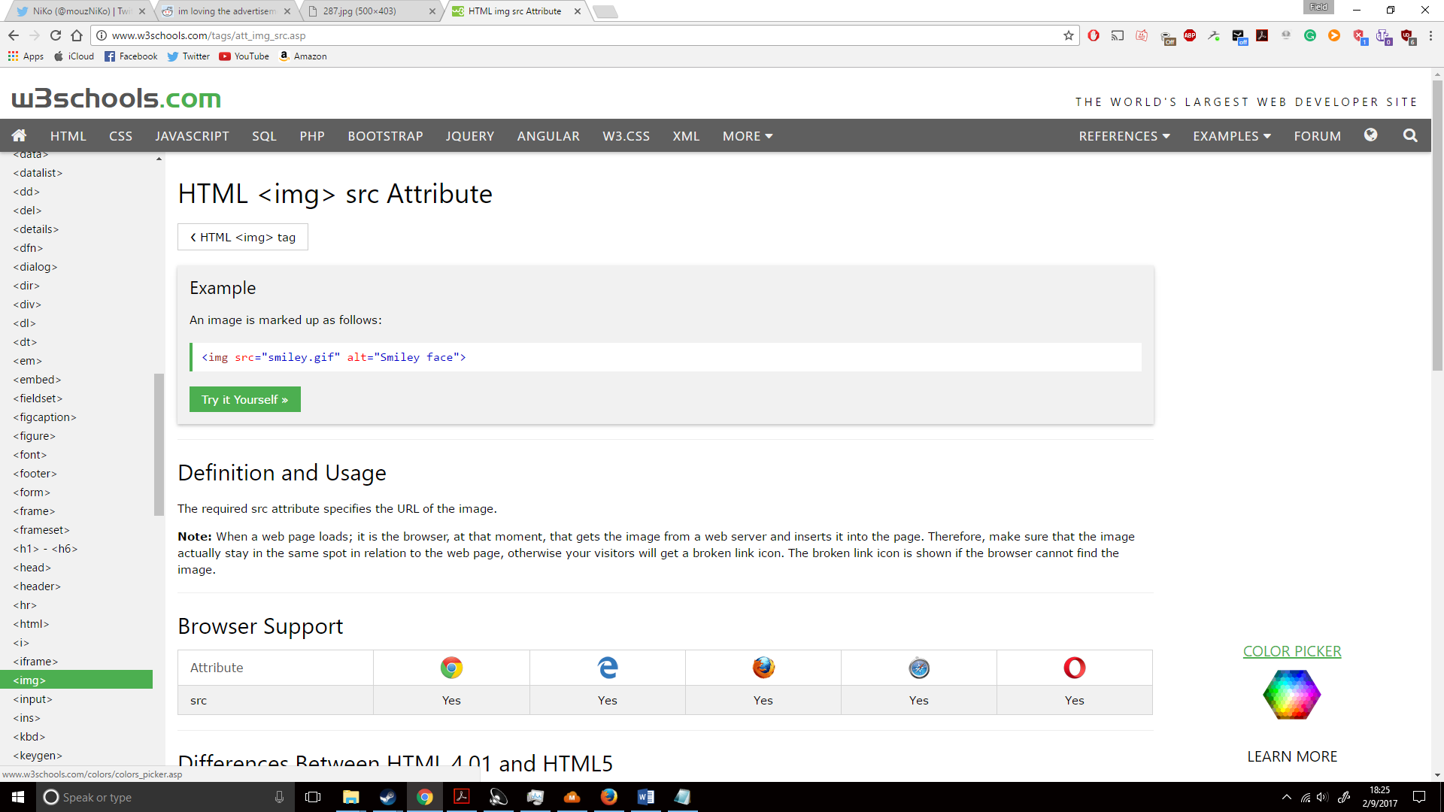

I then added it to my code and it looked like this:

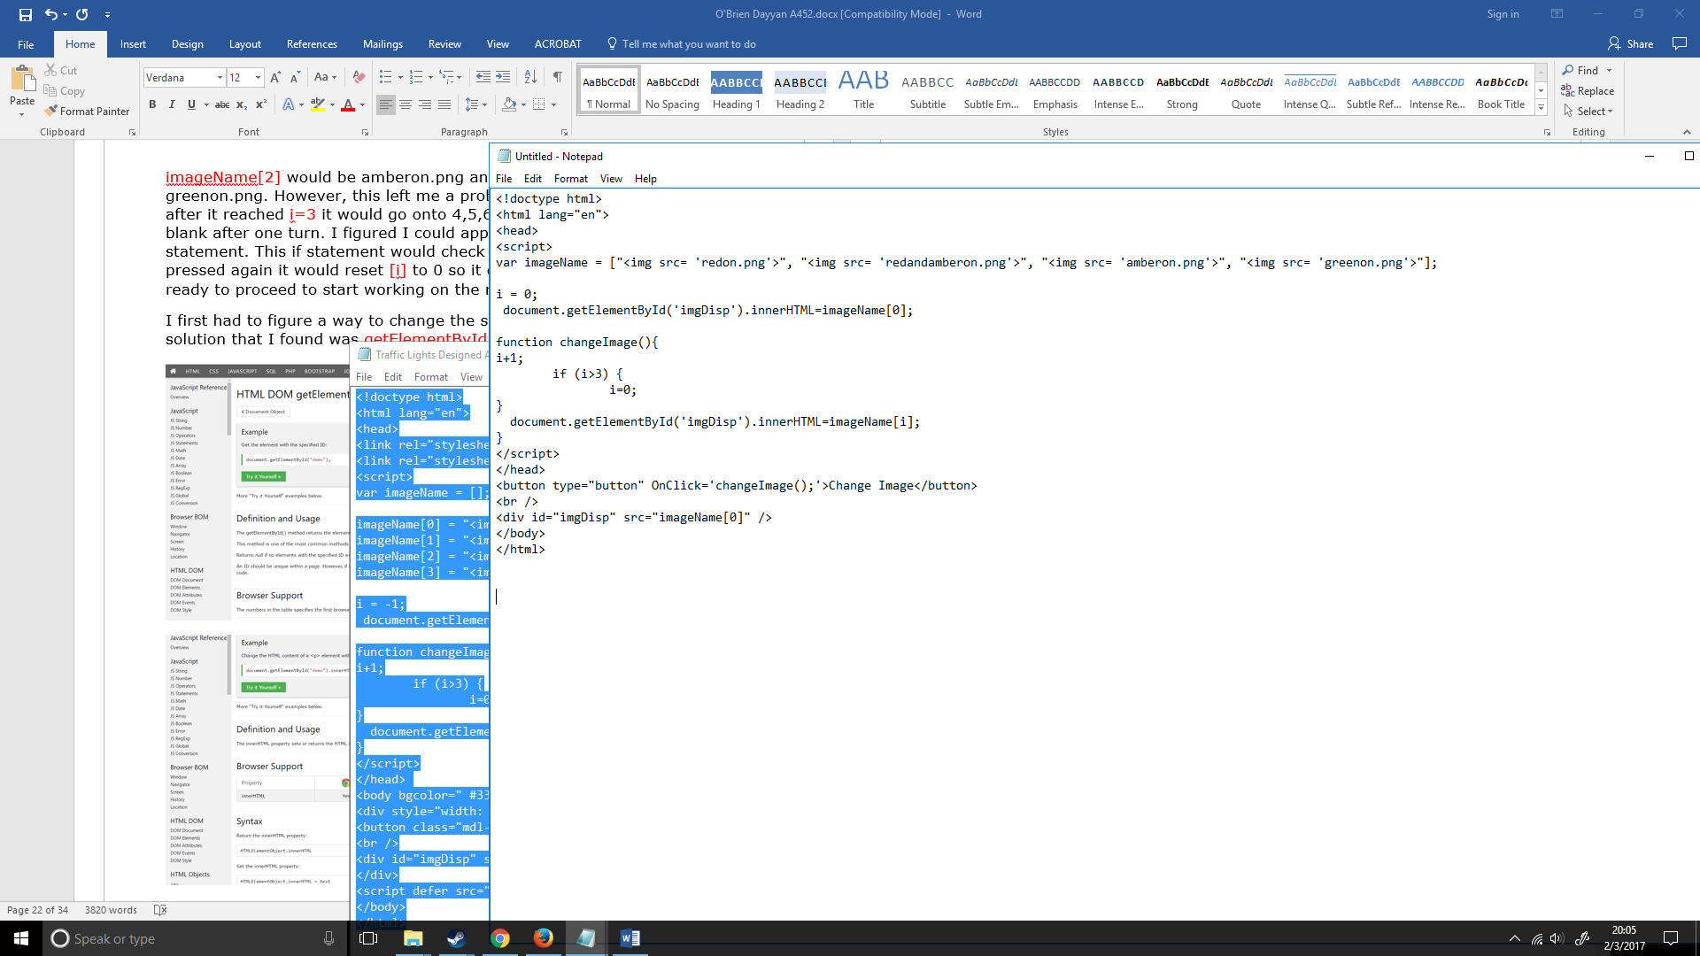

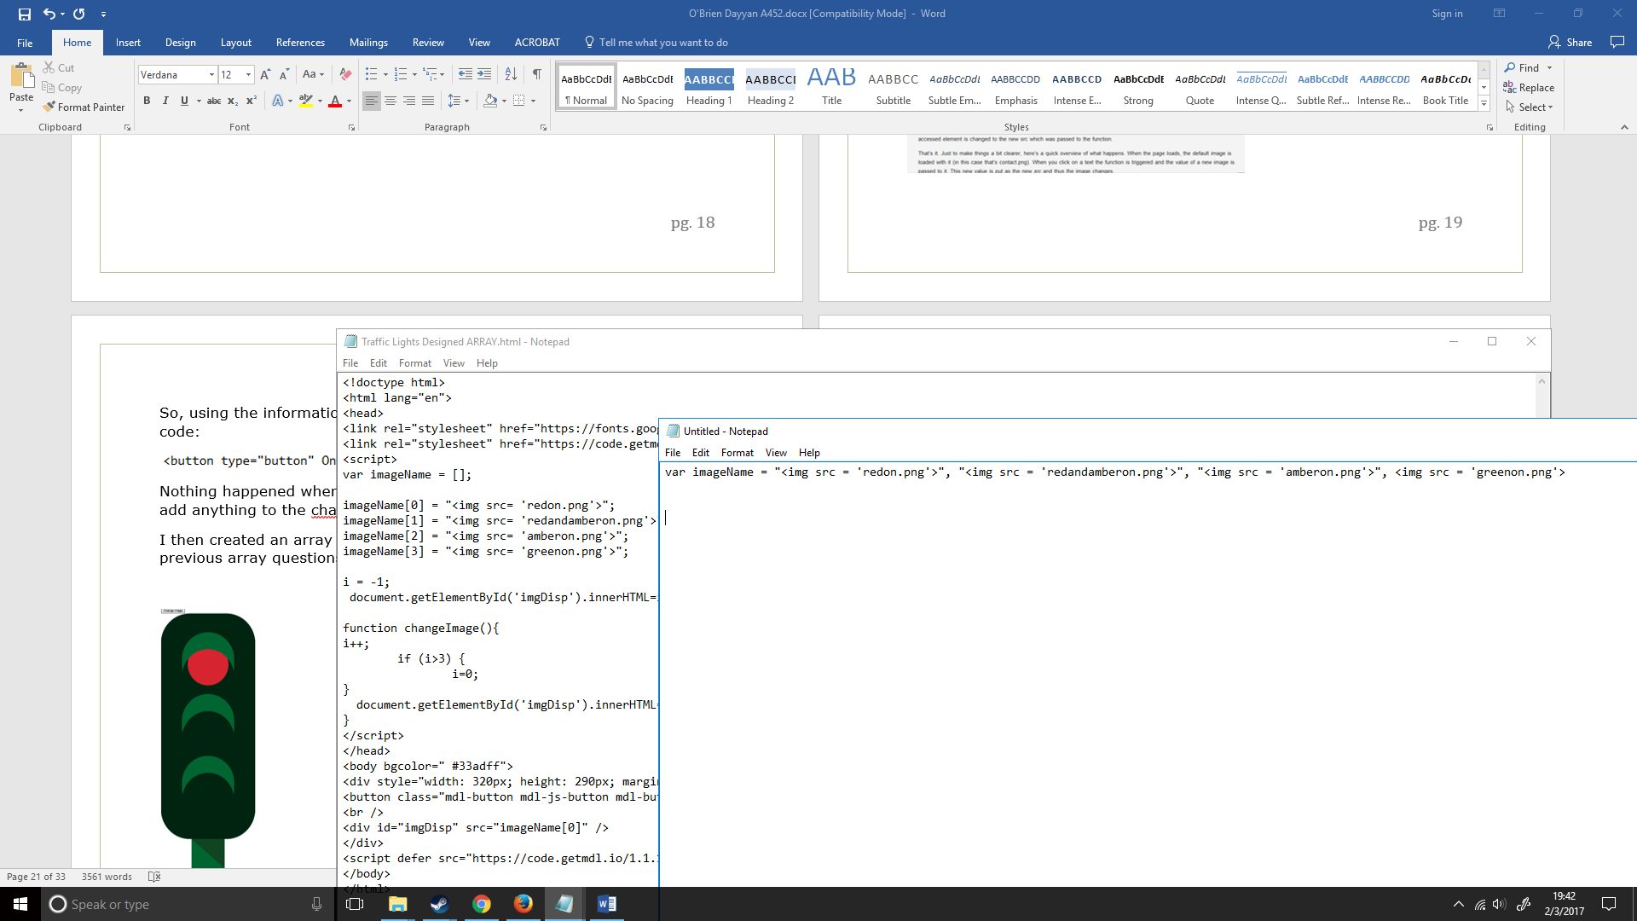

I then tried to run my code again and it gave the following result:

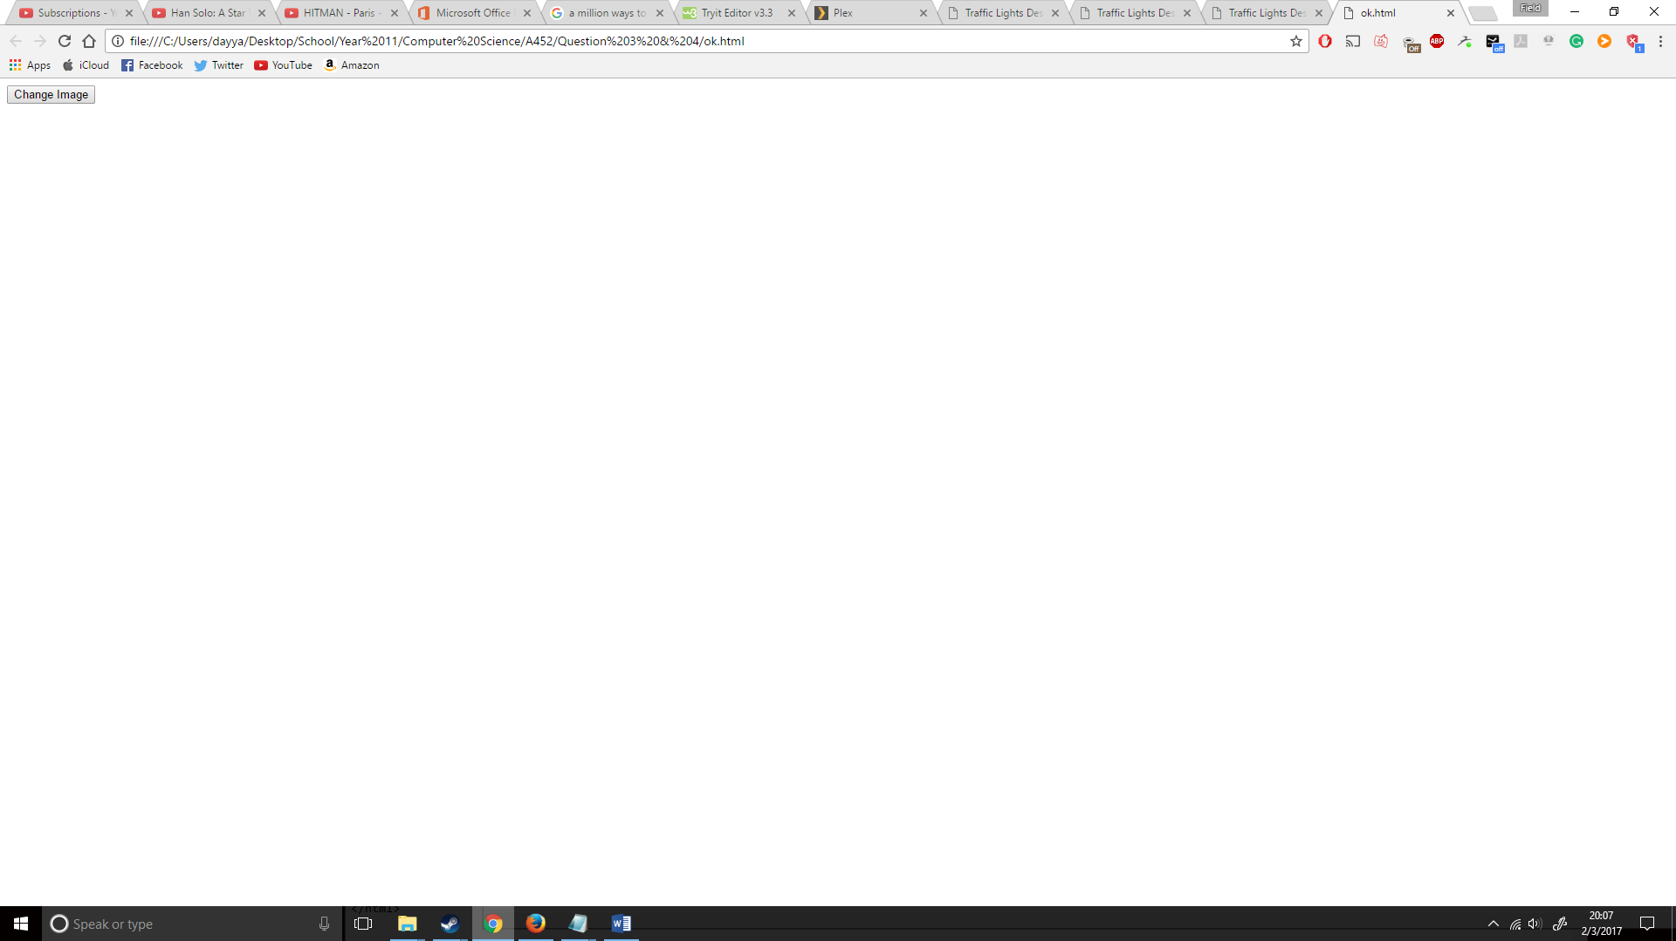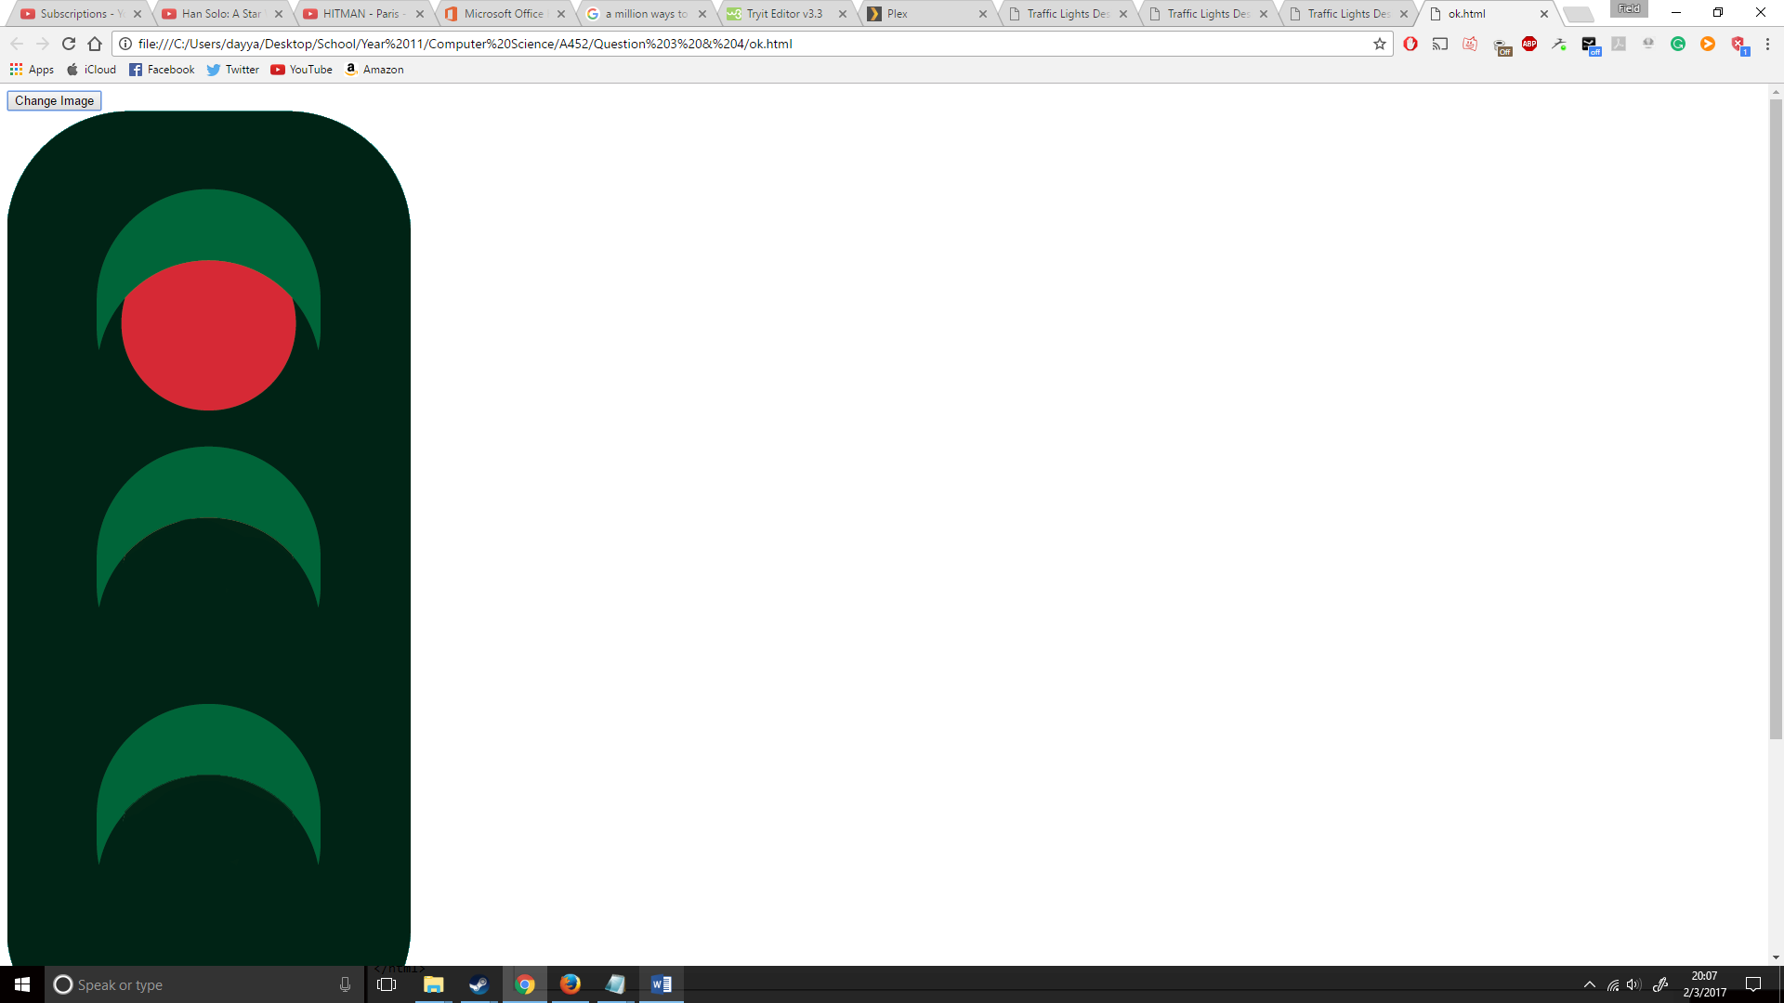

It worked; sort-of. It first gave a blank screen and then went to a traffic light with just the red light showing. But when I pressed the change image button again nothing happened.

The solution I found was that I was using i+1 while I should have been using i++. This is because (per StackOverflow). *“++ converts to number, and then increments, += with a String concatenates” http://stackoverflow.com/questions/4397917/javascript-vs-1*

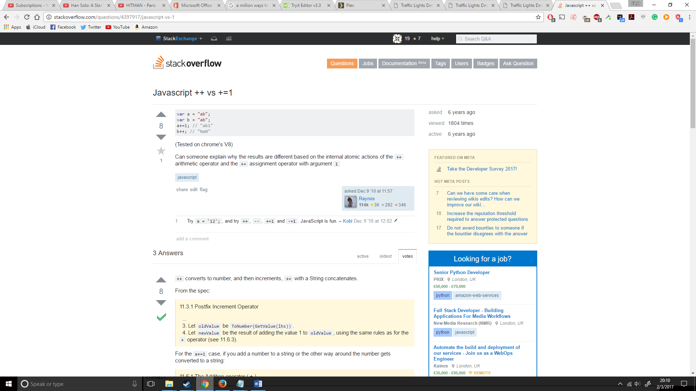

I then replace my i+1 with i++ and it worked like the following:

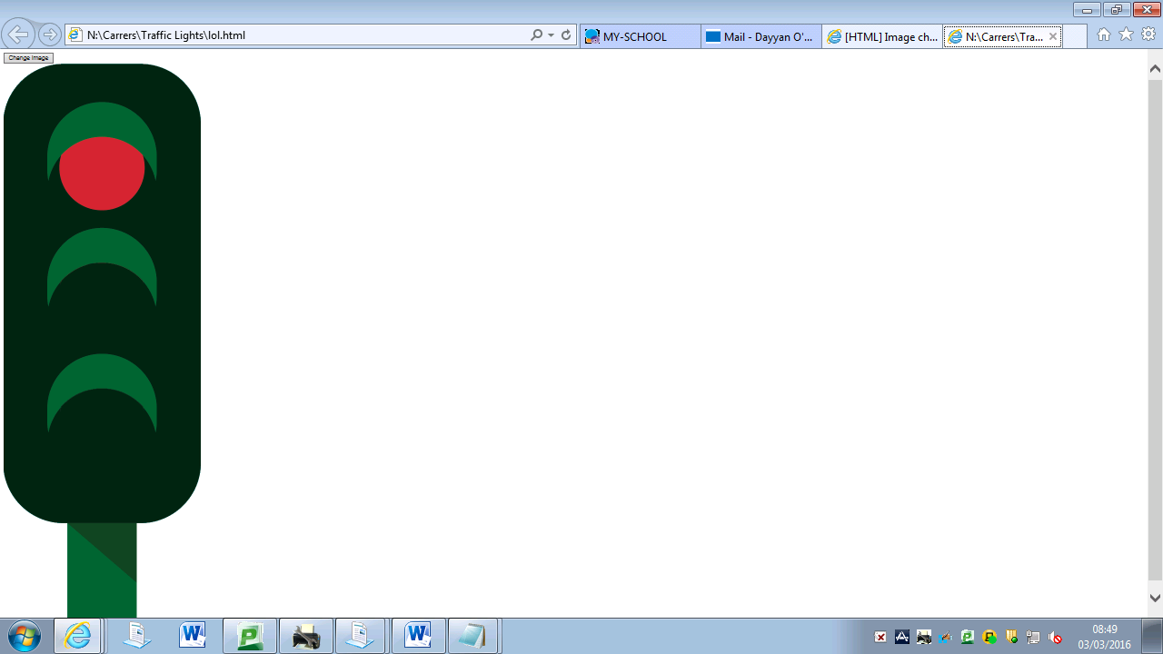

It looked correct thus far, so I then ran the rest to see if it would work.

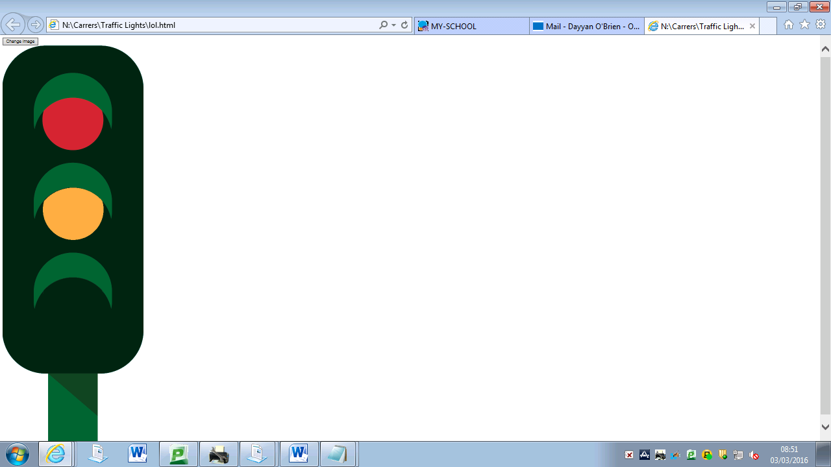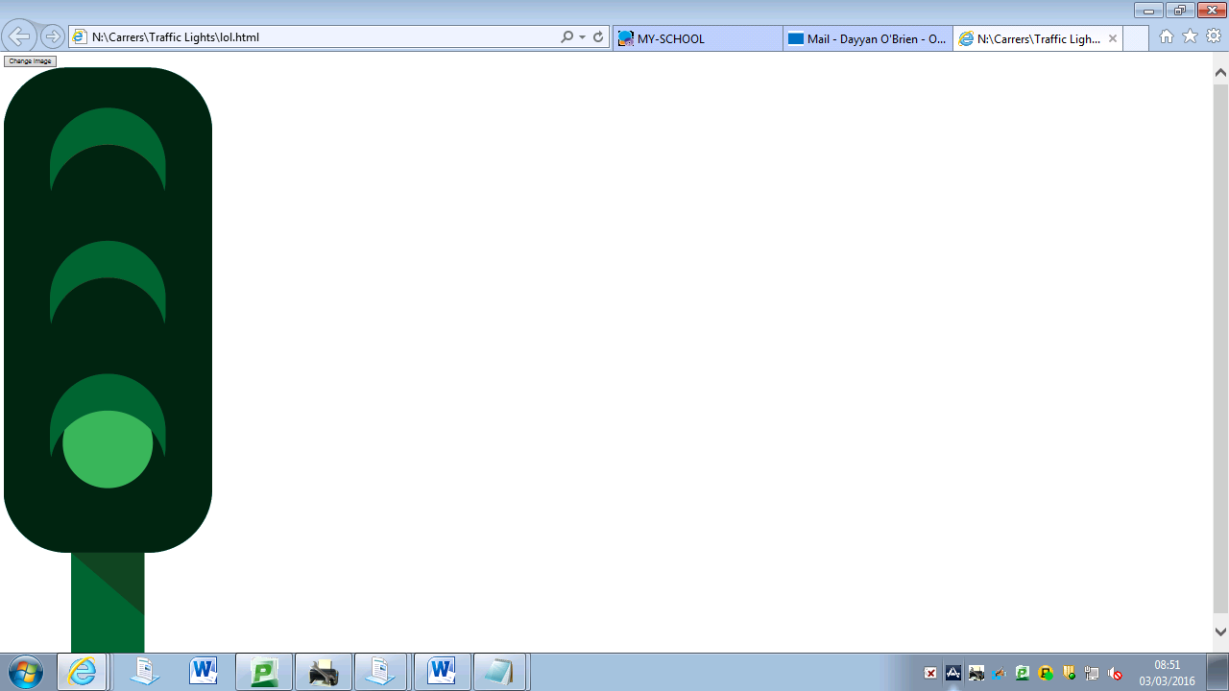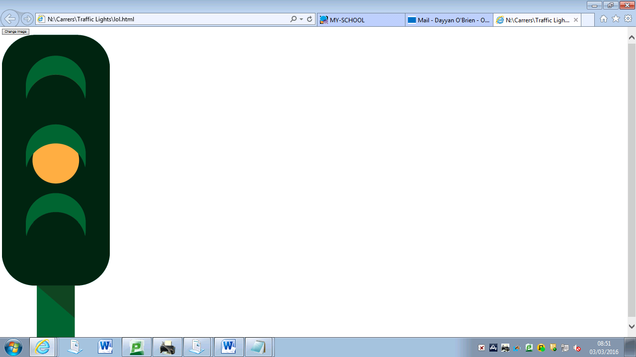

It was fully functional, now to move on.

I then decided to add some aesthetics. These varied from centring the image, using getmdl.io to add some aesthetically pleasing buttons and to add a background. For the background it was simple, I wanted to add a light blue background so I just had to add:

<body bgcolor=" #33adff">

I then wanted to centre the image and the button, so around them I added

<div style="width: 320px; height: 290px; margin: 0 auto;">

And:

</div>

I then proceeded to add the final bit of aesthetics this was the material design for the button, this was the most difficult aesthetic to add. But to do it I had to add:

<link rel="stylesheet" href="<https://fonts.googleapis.com/icon?family=Material+Icons>">  
<link rel="stylesheet" href="<https://code.getmdl.io/1.1.1/material.indigo-pink.min.css>">

to the header:

<script defer src="<https://code.getmdl.io/1.1.1/material.min.js>"></script>

to the body:

class="mdl-button mdl-js-button mdl-button--raised mdl-js-ripple-effect mdl-button--accent"  
within the <button>

So now my fully finished code with aesthetics is ():

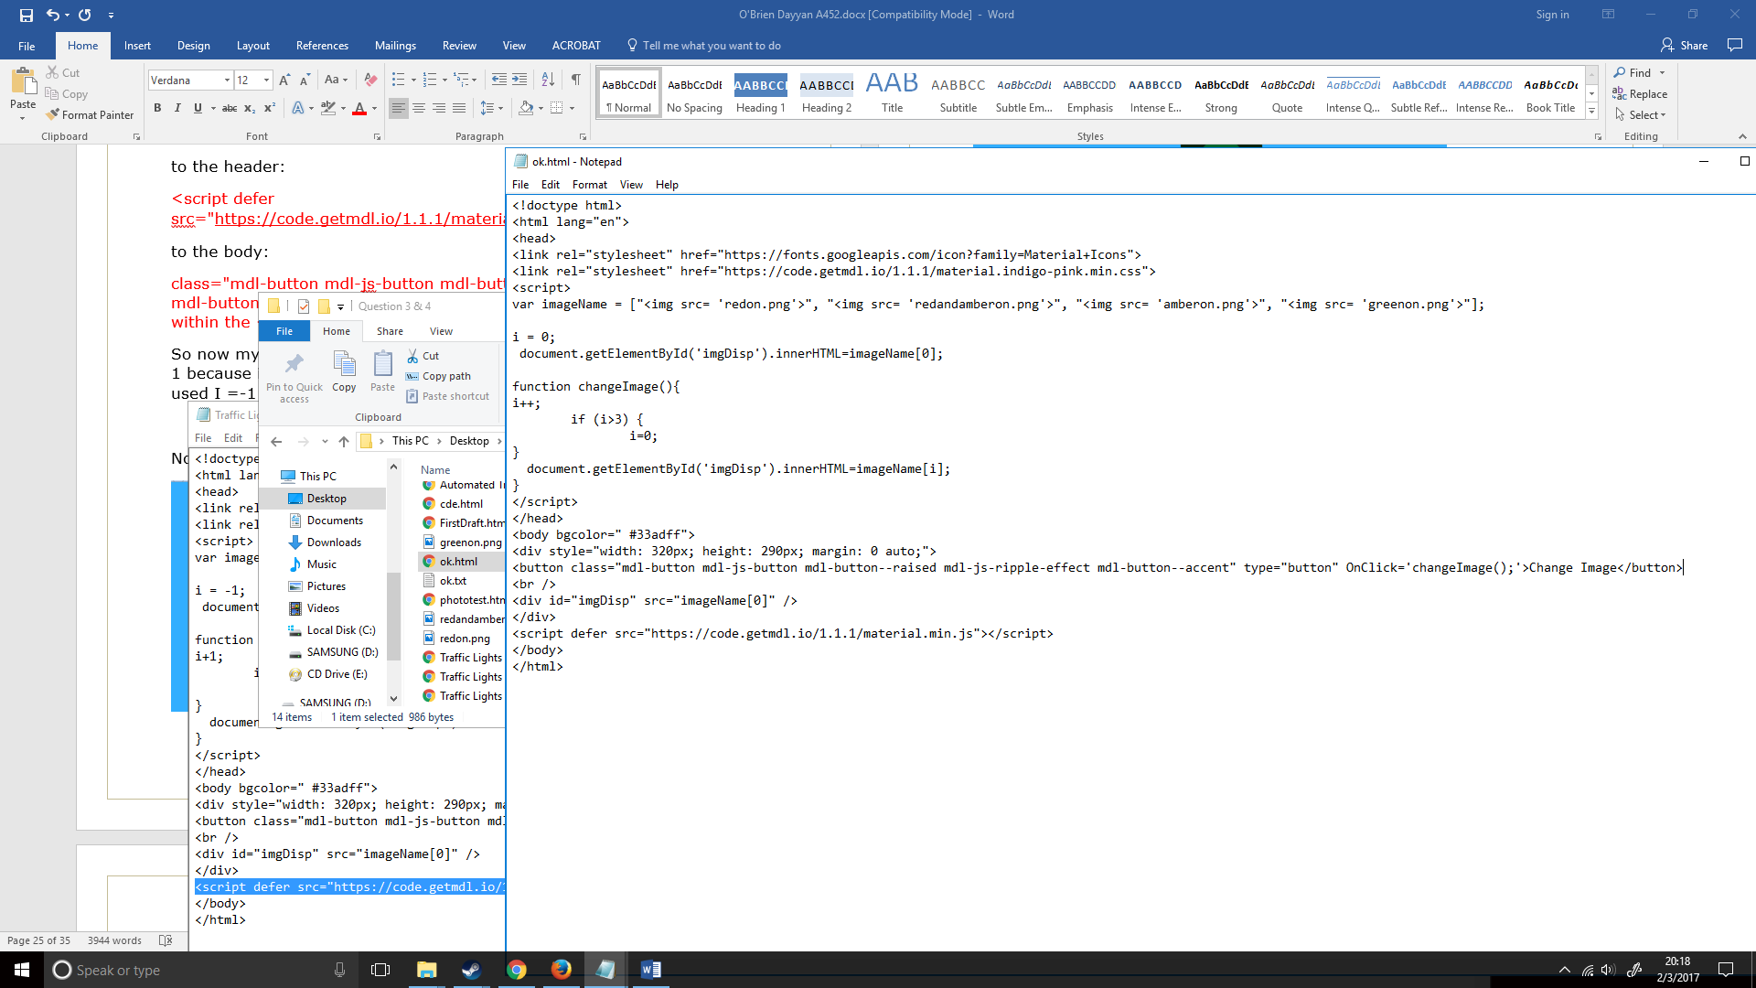

Now let’s look at the traffic light in a browser.

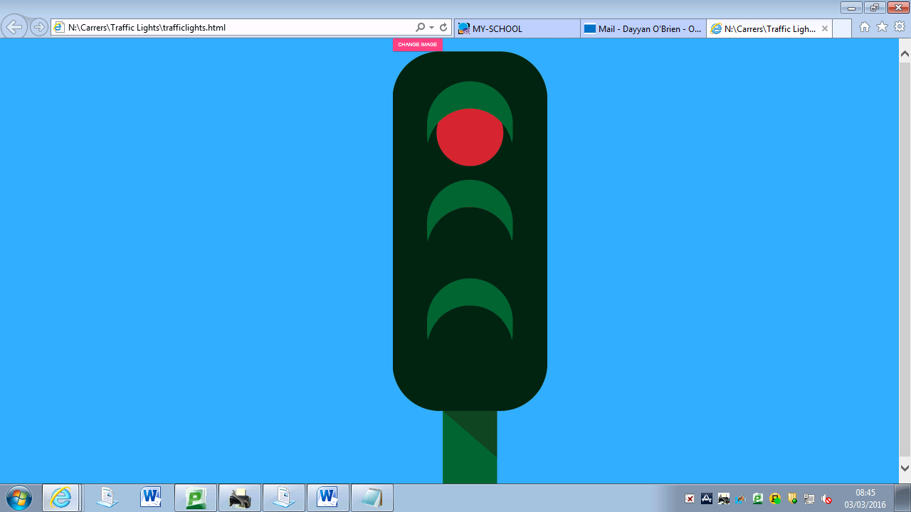

I then pressed the ‘Change Light’ button. This successfully changed the image the button also had the effect I wanted when pressed

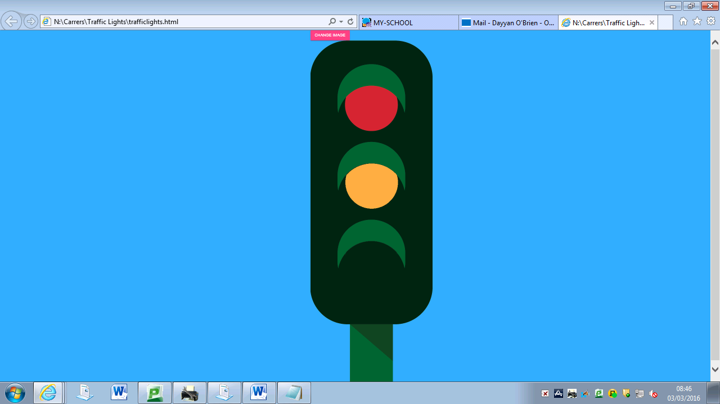

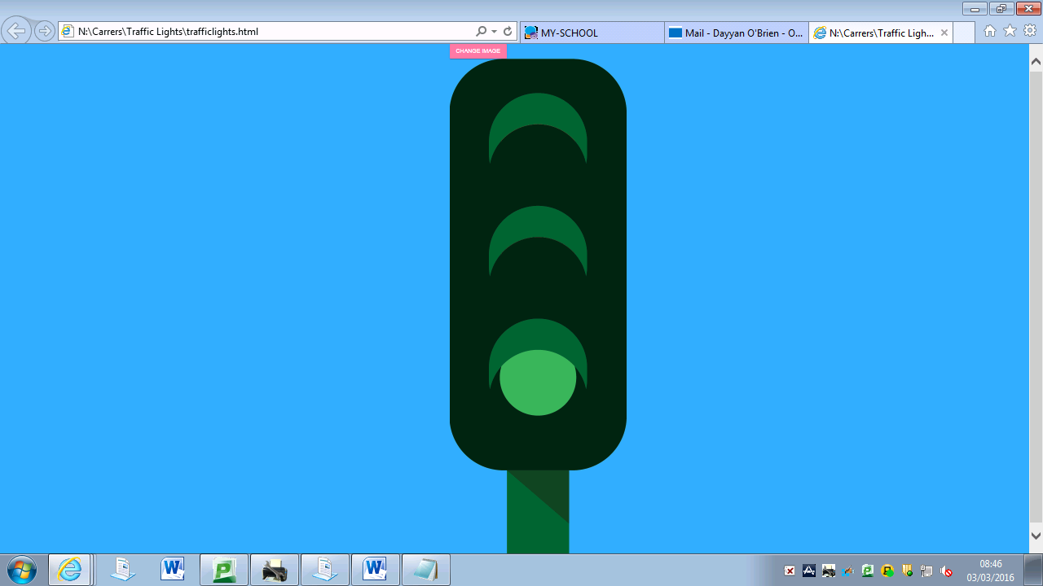

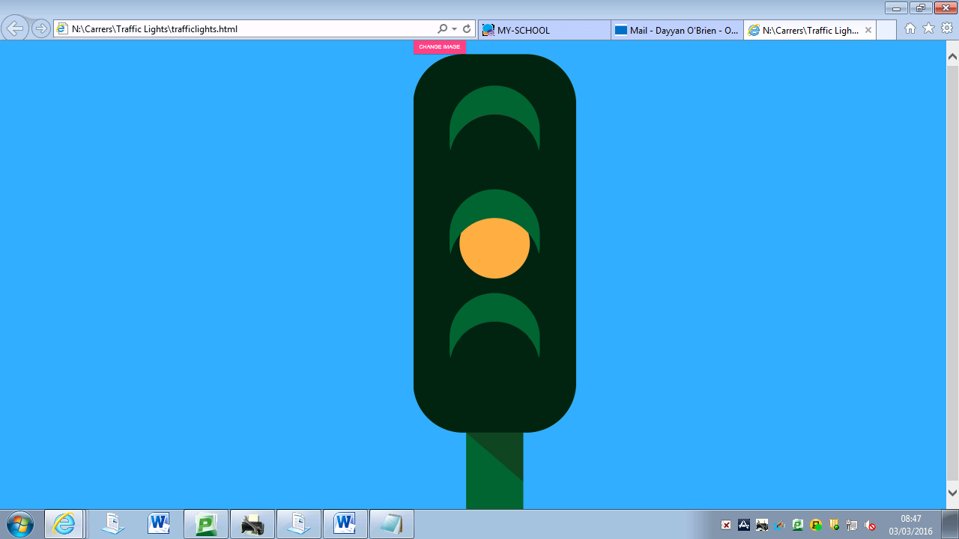

The light fully works; I have now finished the manual traffic light.

**PSEUDO CODE**

At first I didn’t know how to do pseudo code so I looked at my OCR Computing GCSE textbook, which explained to my how to create it. The book showed the following:

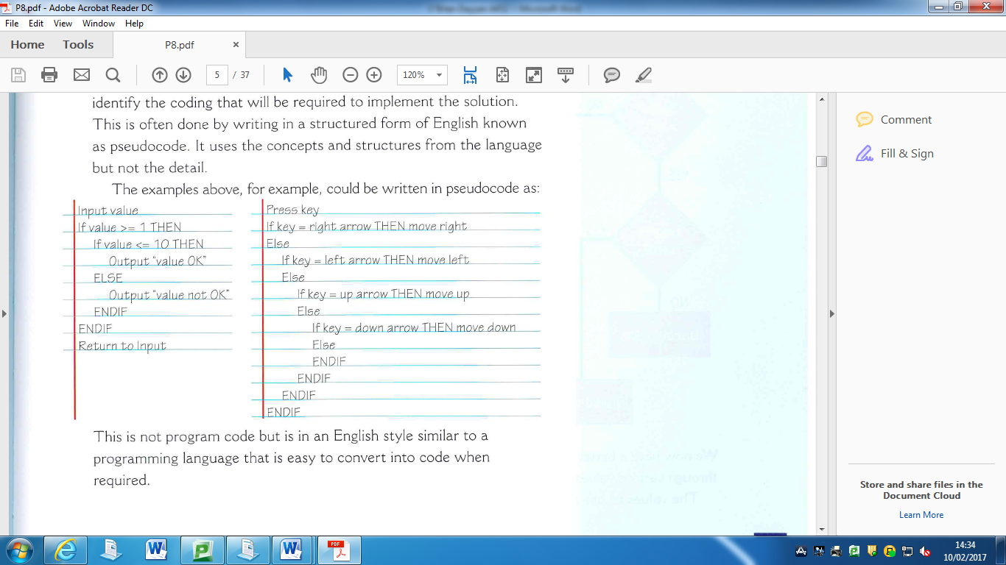

START INPUT ImageName = [redon.png, redandamberon.png, amberon.png, greenon.png]; i=0: MAKE imageDisp redon.png

FUNC ChangeImage; { i++; if i > 3; i = 0 MAKE imageDisp [i], when function ran } IF ButtonPressed; ChangeImage ENDIF

|  |  |  |
| --- | --- | --- |
| DESTRUCTIVE TEST | HOW? | DID IT STILL WORK? |
|  | Spammed change button | It still ran cleanly, efficiently and normally. |
|  | Spammed clicks around the screen | Nothing happened on anything but the button. |

**FLOWCHART**

To make my flowchart I had to learn what each of the shapes meant. To find this out I checked my OCR Computing for GCSE. It showed, for example that rectangles meant process. Here is the page from the book:

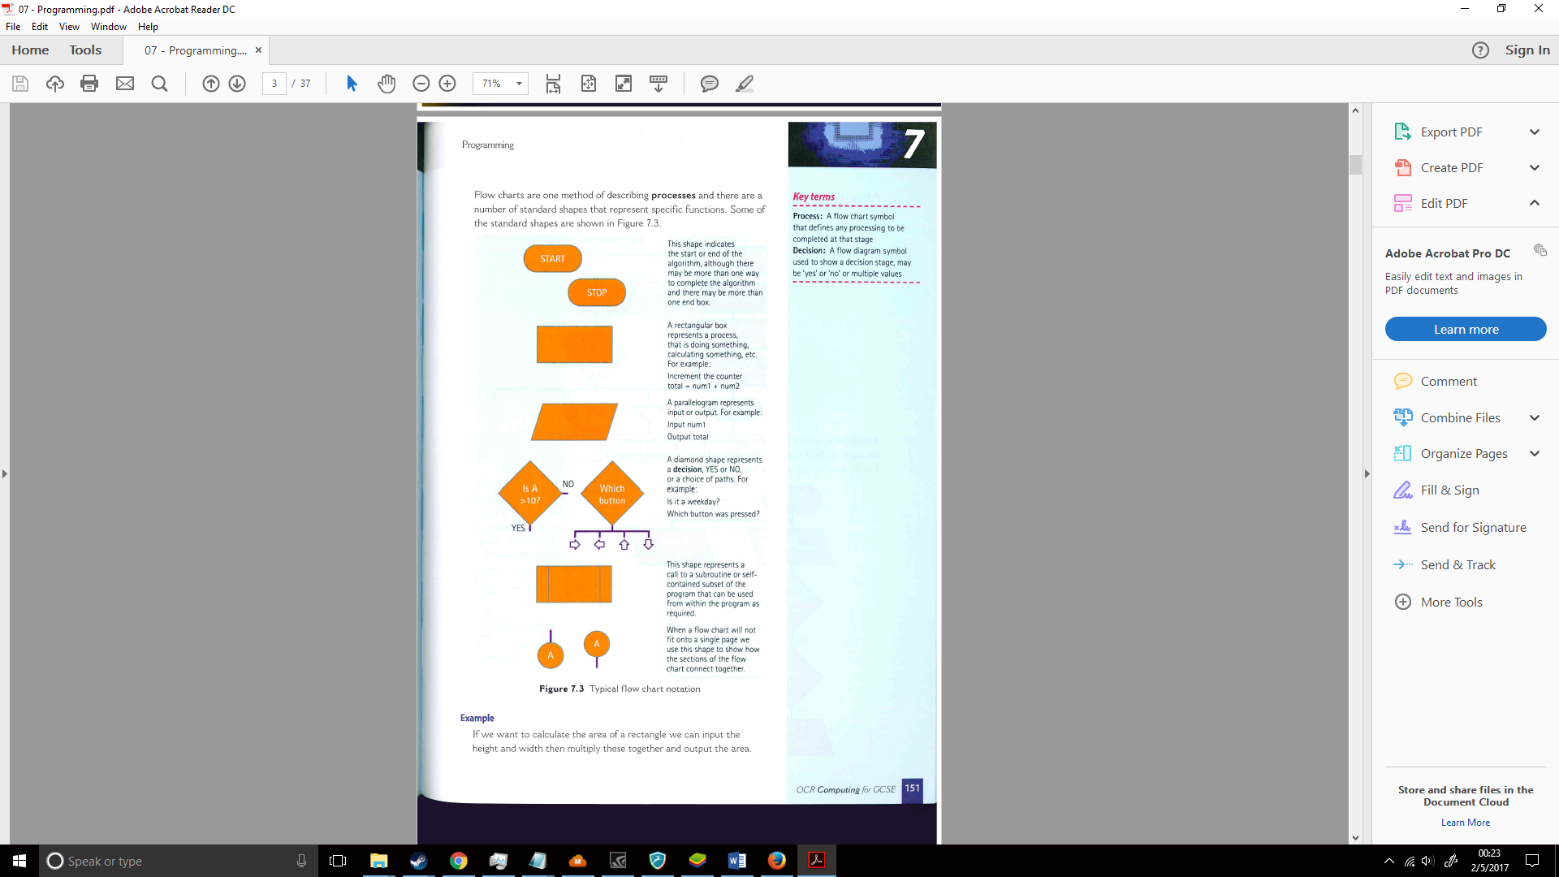

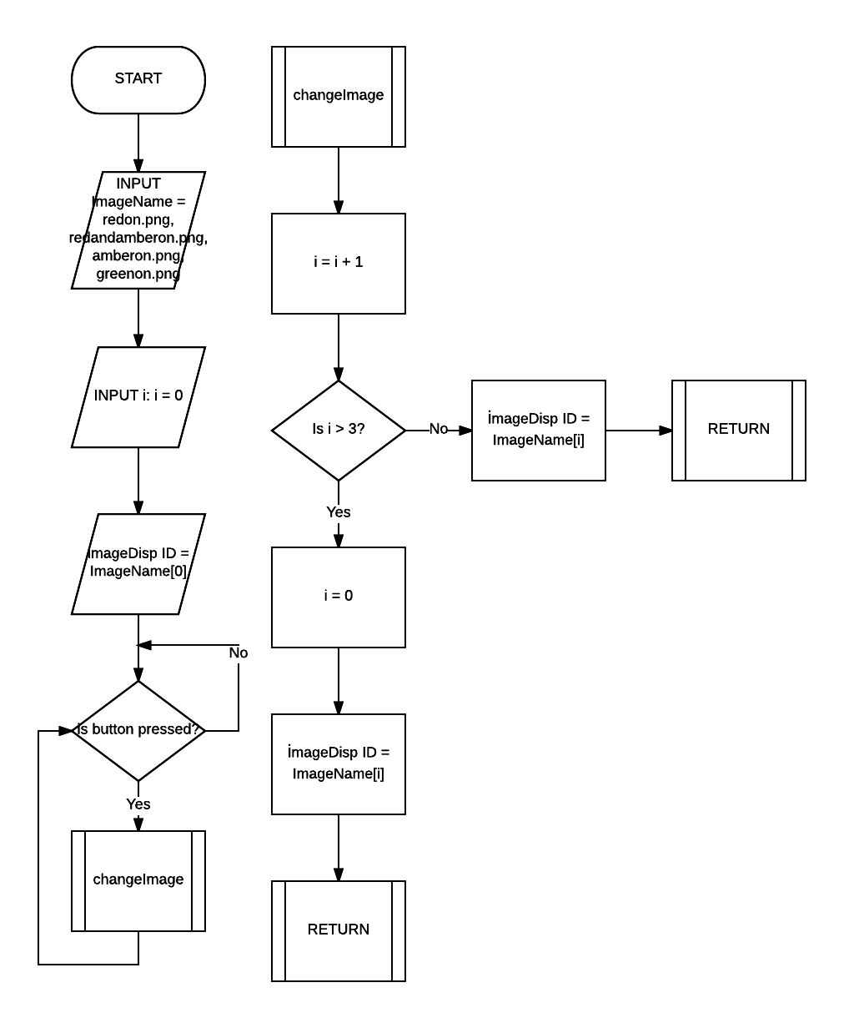

Conclusion: In conclusion, this question gave me a much better grip on JavaScript and HTML and how both respective languages work and preform using algorithms. I better learnt the structure for if and question statements which I feel will be necessary in coding in the future. I learnt how to apply flowcharts to show how my code worked as well as change my algorithm into pseudo code. I also learnt about the getElementById and innerHTML method which was an extremely useful technique I found for changing how images and other visible items looked. I can see myself using this in the future to change a piece of text and other such items of appearance. I also learn how to add buttons to my code (even though I knew how beforehand I forgot the structure and didn’t know how you made a button work from a click.) Furthermore, I learn some CSS which allowed me to design my webpage, this showed me how to change the colour of a background and move an image to a specified place on a webpage into an aesthetically pleasing design. I also learn how to import sources for appearance based items (e.g. the button going in a ripple form when pressed) and give an overall more appealing look. Finally, I looked at the importance of destructive testing and normal testing in code, and while this one didn’t have any errors in the result I can see this being useful in larger and more complex pieces of code to find the root of problems as well as to effectively bug test.

# Question 4:

Change the animation script so that the sequence of lights is displayed automatically on a timed basis without user input.

I will be using my previous code to make the automated traffic light easier to make, but I have to take out all the buttons and styles for the buttons as these wouldn’t help the automation and I could easily do it without them. This was pretty easy as I just needed to take out lines of code that worked with the button (including button styles)

Now I must add automation, at first I was confused about how this would work, but upon research I found the following page on w3schools.com (http://www.w3schools.com/jsref/met_win_setinterval.asp)

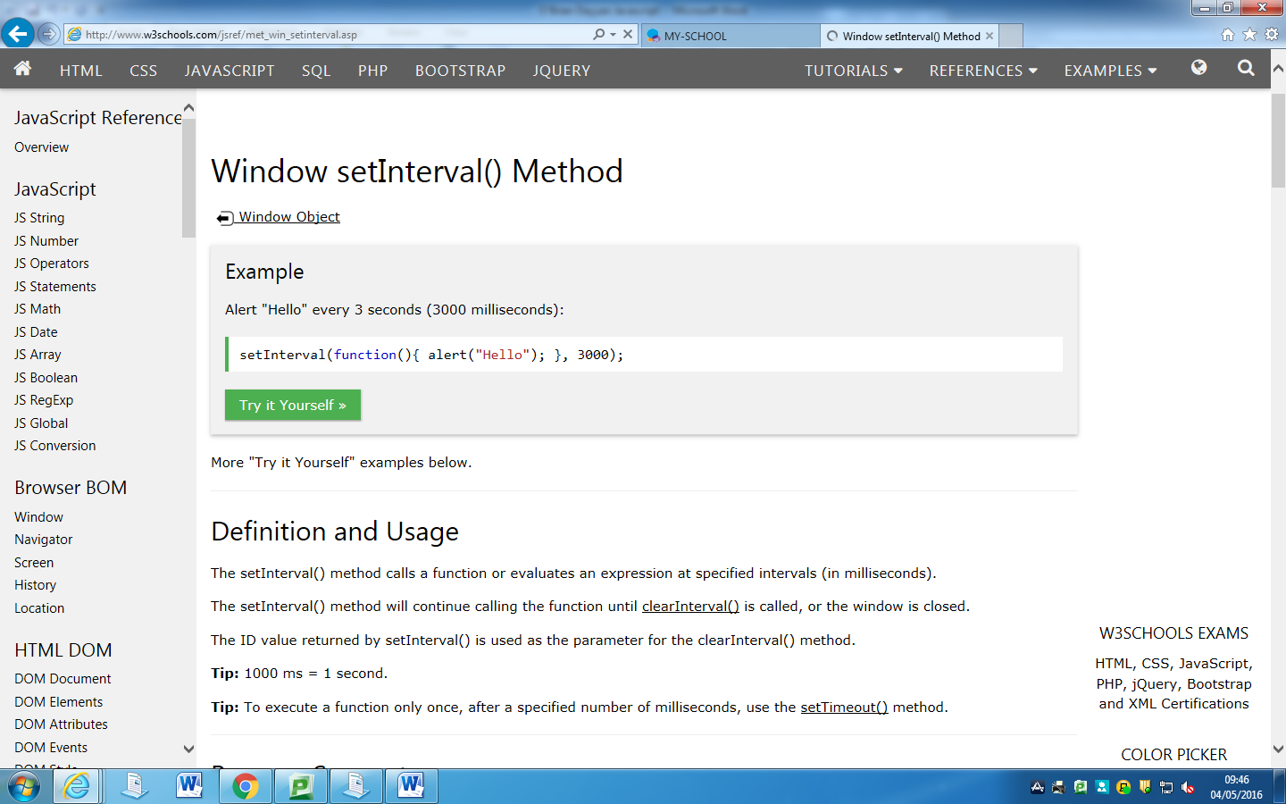

Now I knew all I had to do was add a single line, changeImage would be the function run and 1000ms/1sec the amount of time per interval changed.

setInterval(changeImage,1000);

Which would be within a <script> as this was JavaScript. Now I just had to add the line and this was the full result:

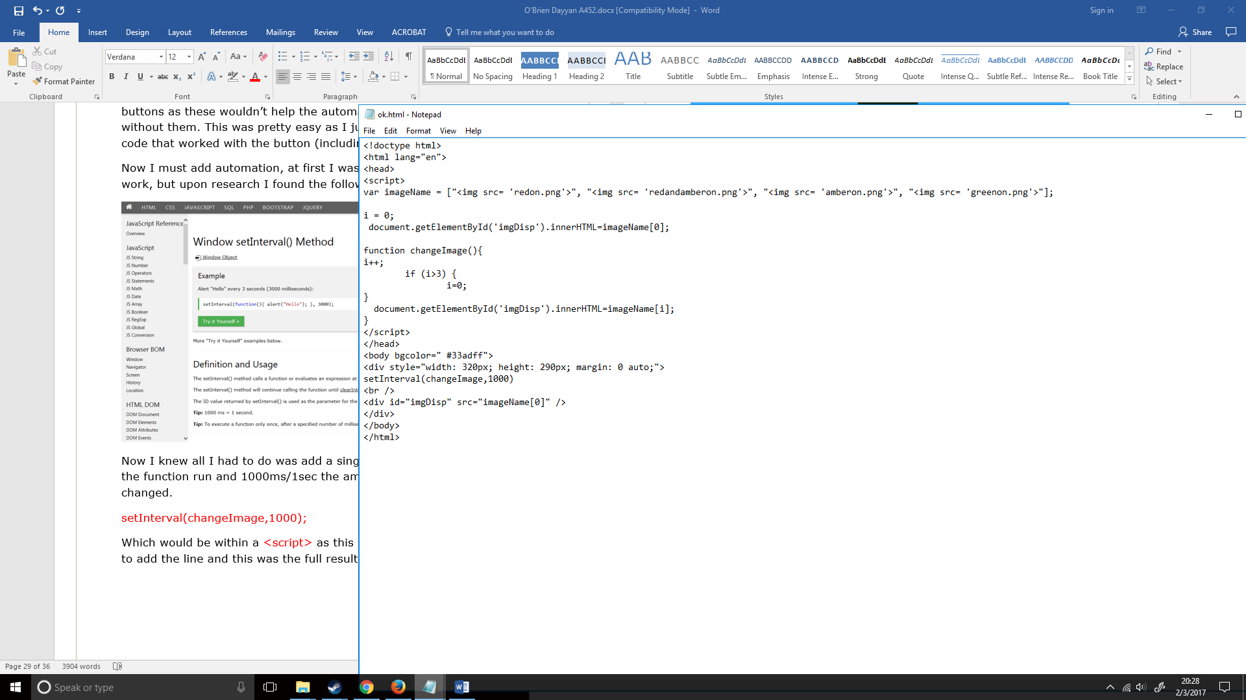

Now to see if it works:

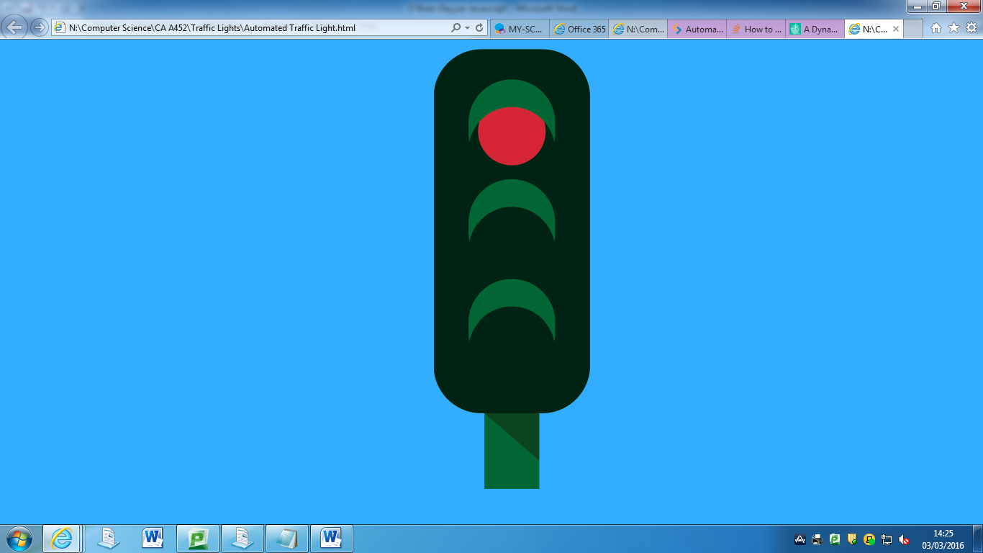

The first starter image came on correctly, now let’s wait and see if it changes by itself.

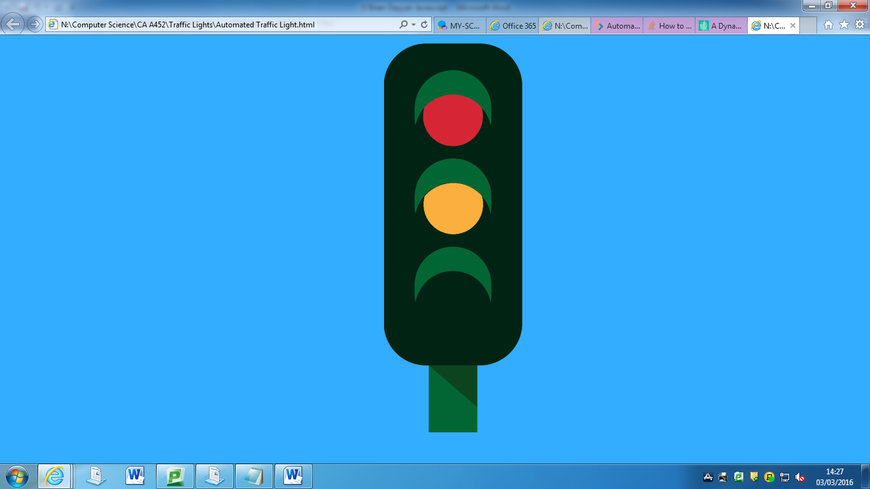

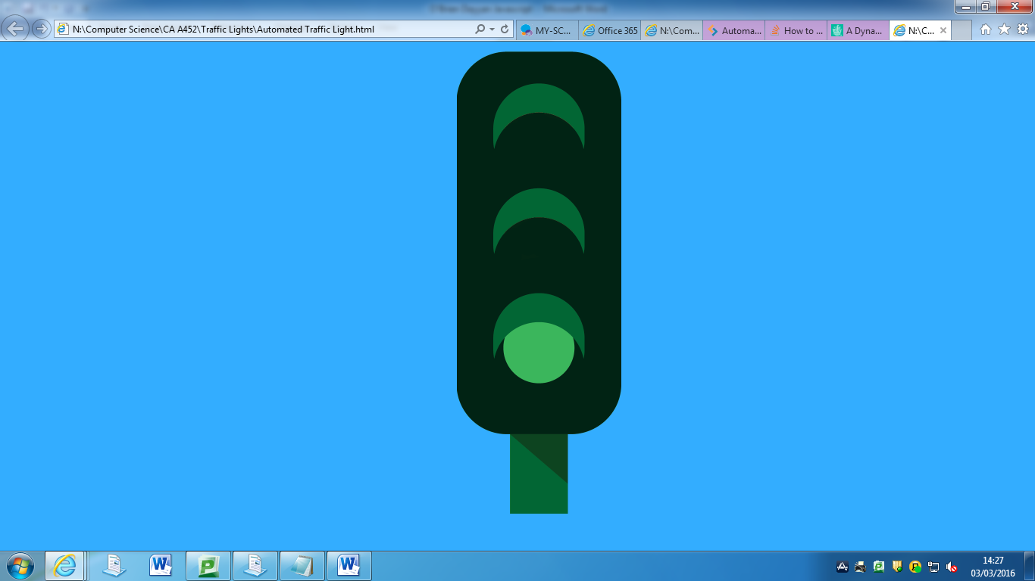

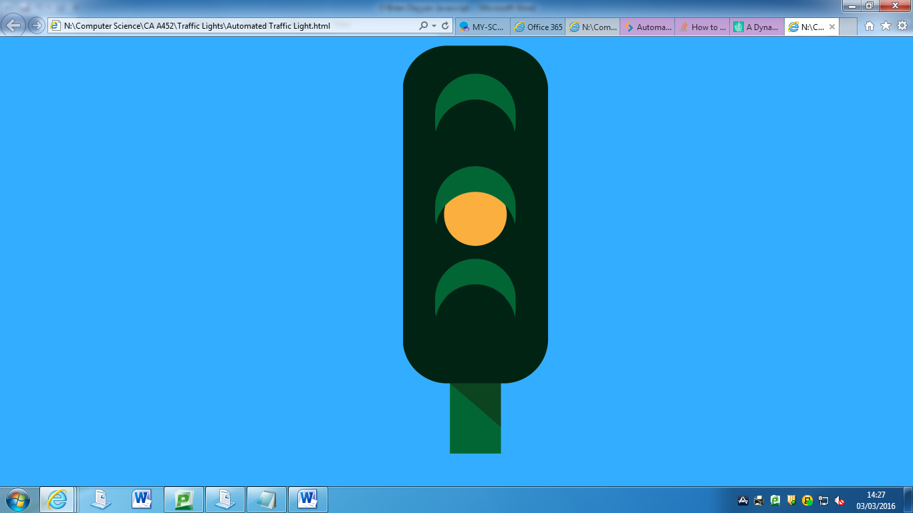

The entirety of the automation is a success

**PSEUDO CODE**

VAR ImageName = [redon.png, redandamberon.png, amberon.png, greenon.png]; i=0: MAKE imageDisp redon.png FUNC ChangeImage; { i++; if i > 3; MAKE imageDisp [i], when function ran } EVERY 1000MS RUN ChangeImage ENDIF

|  |  |  |
| --- | --- | --- |
| DESTRUCTIVE TEST | HOW? | DID IT STILL WORK? |
|  | Spammed clicks around the screen | Nothing happened on anything but the button. |

**FLOWCHART**

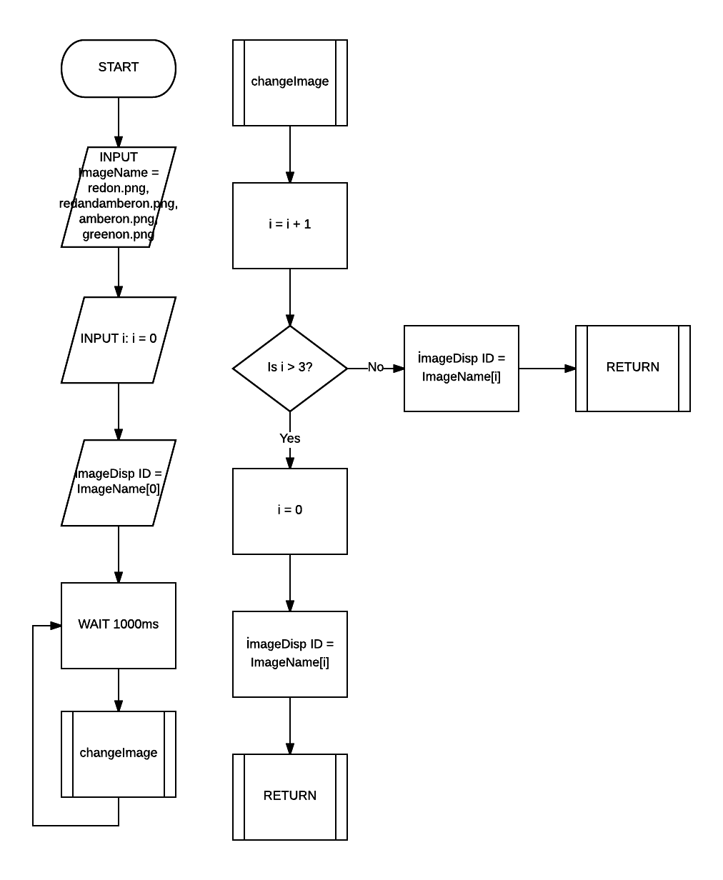

Conclusion: To conclude, while this question wasn’t particularly hard as I did most of the work in Question 3 (iv), it helped me learn how easy it is to apply a seemingly complex piece of algorithm with a short amount of code. It also told me about the importance and use of using functions and I will use functions more effectively in the future to connect everything more easily as well as making my overall code shorter and more efficient. It also showed me how re using code is extremely useful especially if what you are trying to do is likely to be used again at some point in the future (e.g. the changeImage function on a website where it goes through a gallery of images over time).

# Question 5:

Scripts can be embedded in the HTML of web pages or saved externally as script files. Discuss the benefits and drawbacks of each approach.

Initially I was confused about what this question meant, I knew what external meant in modern day English, but I was not sure what inline meant (I expected internal though, as that’s the opposite of external). I knew that research would be required for this question so I decided to do some research on Google searching things such as “What is inline JavaScript?”, “What is external JavaScript?” and “Inline vs External JavaScript”. Unsurprisingly I found some websites that have already helped me a lot, such as stackoverflow. This gave me a relevant understanding of both meanings; however, I am still confused about what exactly each of them means due to the technical language in the answers. I understood the pros’ and cons of both better and looked up the definition of word in those sentences which I didn’t understand (such as async, defer & server side rendering.) Most of the information was found on stackoverflow, w3schools & technopedia. I found out inline is generally seen as the worse-off choice as most people prefer external because it is cached. I also found out that external uses .js and inline uses <script>.

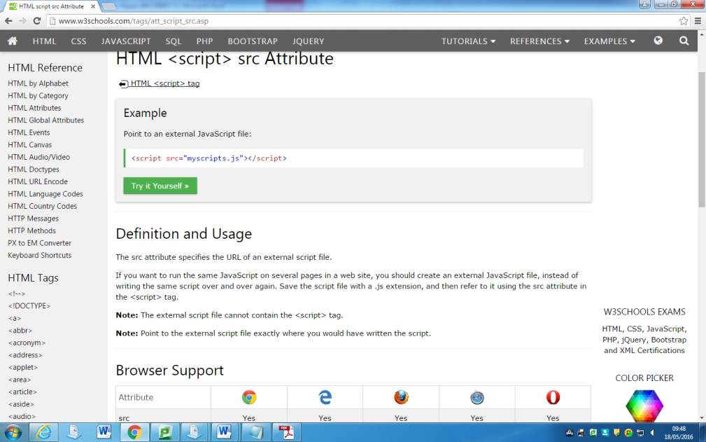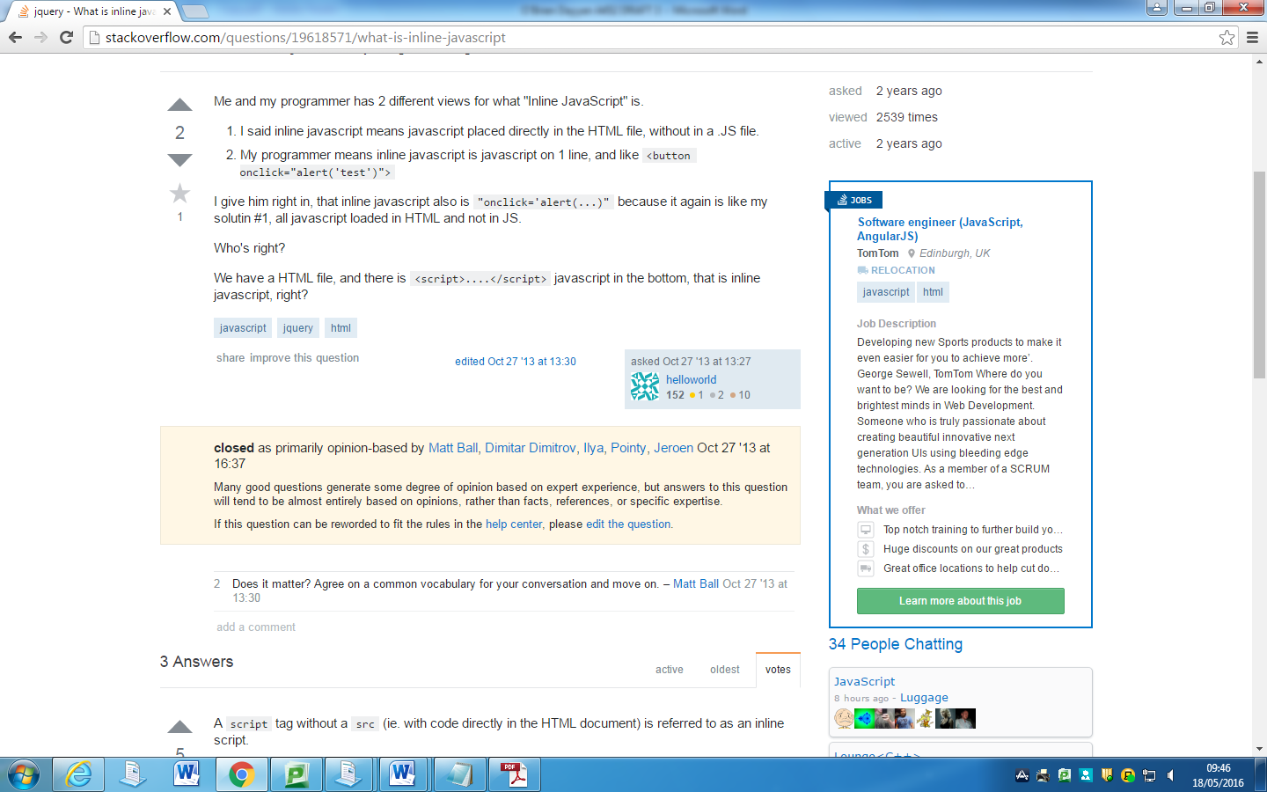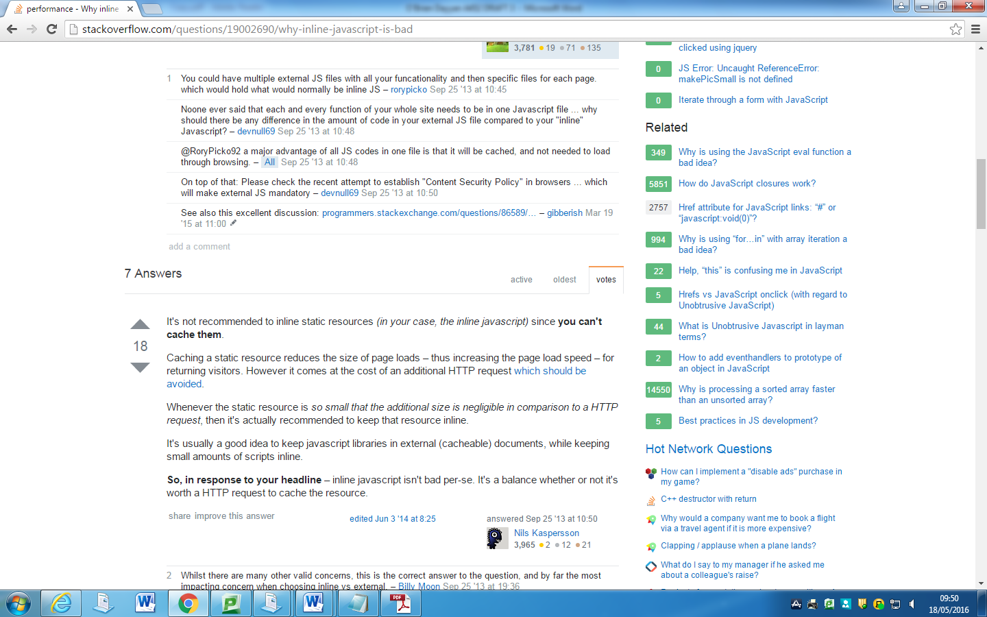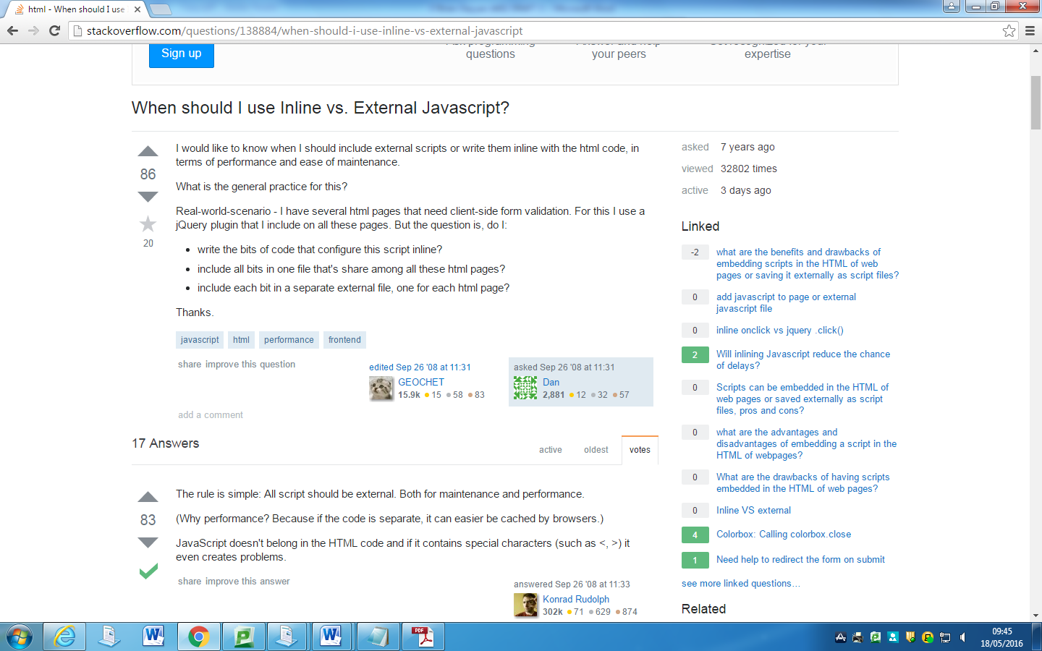

What is inline?

Inline code is code that is added to the body of the program. Normally, inline code is embedded within the loop of the program body rather than being called as a separate function. I have used inline code on all the previous questions however this was before I researched on inline and external.

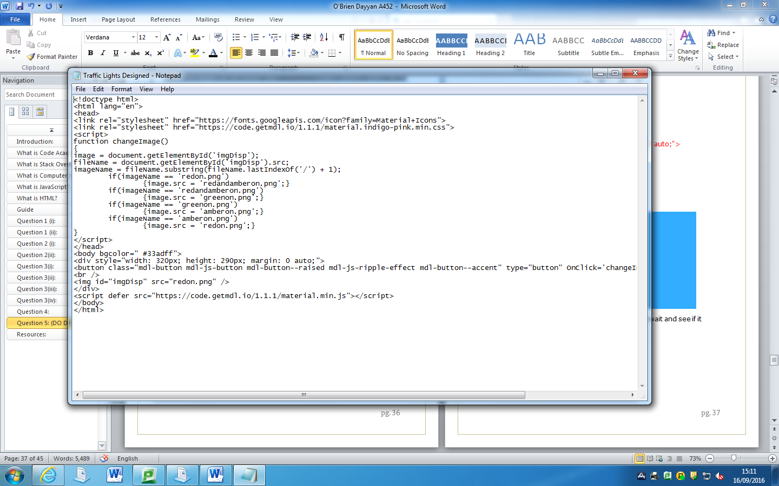

<script> is used here. This is an example of when I used inline code in my own project.

Source: Technopedia (<https://www.technopedia.com/definition/12859/inline-code>)

What is external?

External code is code which is saved somewhere else, for example in a separate file and is linked to the main file. .js is used to save these files.

Inline:

* It’s usually better to use inline if it is the case that your script is around one line long or the script is shorter in inline than it would be if you use external.
* The scripts will be executed immediately.
* The attributes async and defer have no effect, because those attributes can only be uses in external code. Async and defer means (according to <http://www.growingwiththeweb.com/2014/02/async-vs-defer-attributes.html)>:,

“*async downloads the file during HTML parsing and will pause the HTML parser to execute it when it has finished downloading.*”, and defer means (from the same link),

“*defer downloads the file during HTML parsing and will only execute it after the parser has completed. defer scripts are also guaranteed to execute in the order that they appear in the document*.”

* Inline is usually better when you are using “*server-side dynamic rendering*” (server side rendering means your request will load the layout, CSS, JavaScript, content and page.). This means the scripts & content are all loaded in the same page so there is no need to send another request.

External:

* In external the async and defer attributes will have an effect, unlike inline. Normally you would prefer to use async (unless the script relies on another one, in which case you should use defer), then defer, and then no attributes (in order of importance).
* External scripts will be cached so if you need to get it again on another page it doesn’t need to be downloaded again.
* You can use the cache to load “*client code*” when requested and this will subsequently reduce the total size and the time needed to download.
* It’s a lot easier to reuse the code.
* External code will have to make a HTTP request (meaning “*Whenever your web browser fetches a file (a page, a picture, etc.) from a web server”* Source: http://rve.org.uk/dumprequest); this in turn will make it slower.

Overall:

Using external is the best bet, it is faster, more maintainable which makes the code much easier to use as a whole. Though, inline is good for things such as one-liners. External caches the page while inline does not, this makes external load faster.

Conclusion: For question 5, I feel this gave me a much better grasp on the theoretical view of Computer Science, it showed that it’s not just how your pseudo code looks, but the amount of ways in can be used more efficiently and neatly. As for the whole task, this task (as said previously in the conclusions of other questions), gave me a much better understanding on how HTML and JavaScript works. I have learnt many techniques and ways to apply my code in the future. I also have a much better understanding on how certain parts of it work as I didn’t really understand it when studying on code academy.

# Resources:

All direct links are added when needed, see appropriate section to see resource

stackoverflow.com some questions regarding errors, for example i+1 vs i++

w3schools.com meaning of lots of lines e.g setInterval(), <img src> & getElementById

new2html.com buttons

uk.answers.yahoo.com inline vs. external JavaScript

youtube.com inline vs external javascript

google.com (pop-up related to search) meaning of certain lines

OCR Computing for GCSE (book) helped learn parts and how they work as well as the meaning of all the shapes in a flowchart. Pseudo code too.

getmdl.io button assets

codeacademy.com learning basic coding skills

class discussions pseudo code

google images & photoshop finding traffic lights and editing them (no background)

growingwiththeweb.com defer and async attributes

technopedia.com inline code definition

rve.org.uk HTTP request definition